International Training
National Championship FISAC 2022
7th International Acrobatic Cup for Clubs 2022

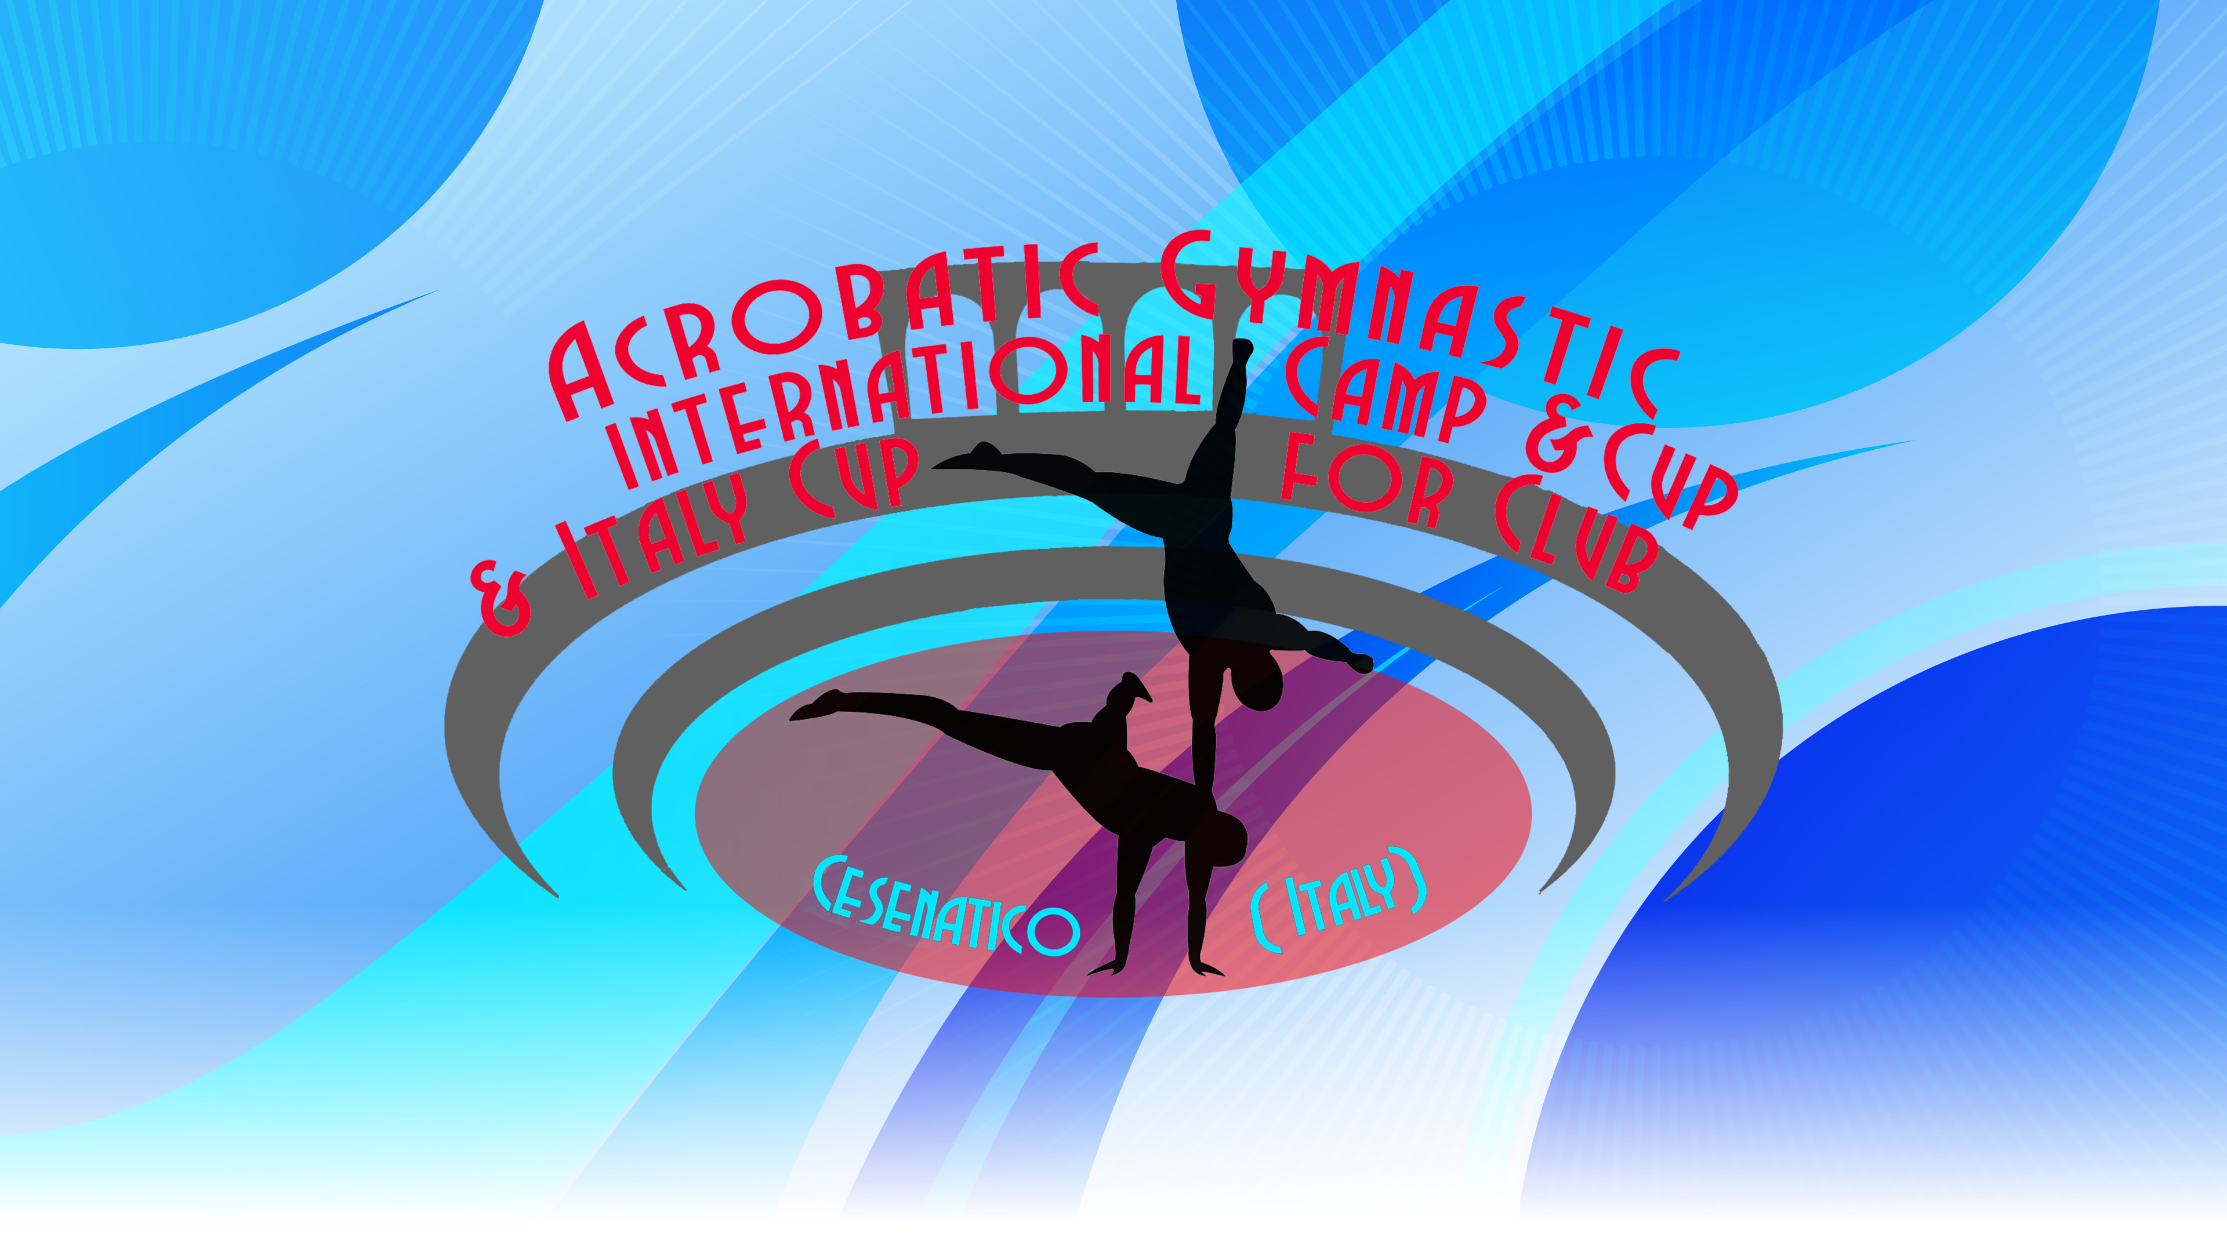

CESENATICO ITALIA
April 2022
- International Training 14 - 15/04
- 7th International Championship FISAC Cup - for clubs 16 – 17 /04

FISAC’s goal for prosperity and development of Acrobatics in Italy and Europe is due to success of the International Team Gym Cup in which 15 countries now participate with well over 70 teams from different nations.

Over 300 Athletes have participated from different clubs and nations such as Bulgaria, Germany, Moldova, Hungary, Portugal, United Kingdom, Ireland, Puerto Rico, Switzerland, USA, Wales, Austria, Ukraine, Israel, and Italy.

With the collaboration of the Acrobatic Academy of Cesenatico, Federal National Technical Head Quartier, FISAC will offer at the participants substantial economic help to this international competition and at the NATIONAL CHAMPIONSHIPS 2022!

FISAC NATIONAL ACROBATIC CHAMPIONSHIPS will be open to all Clubs (Sport Clubs) and federations.

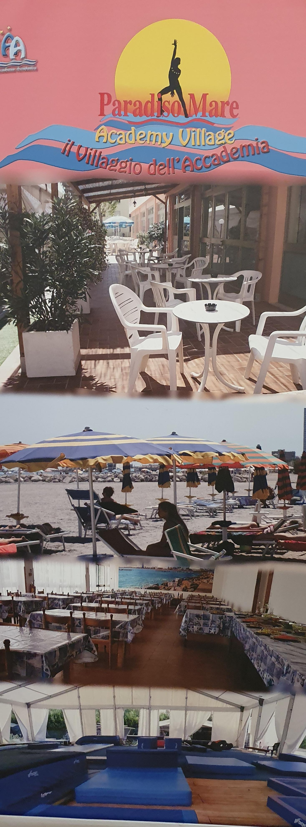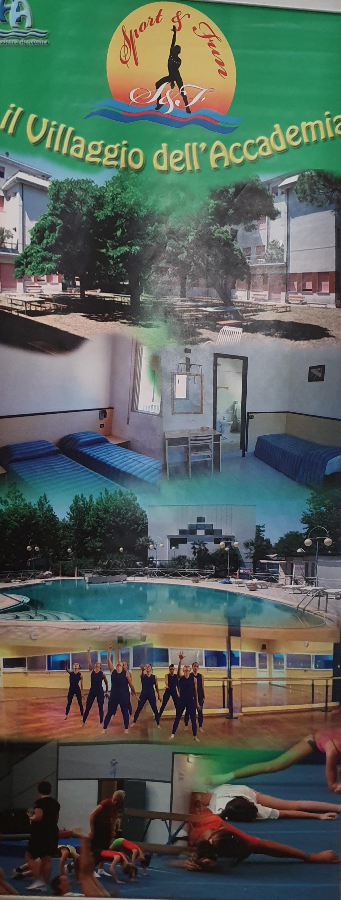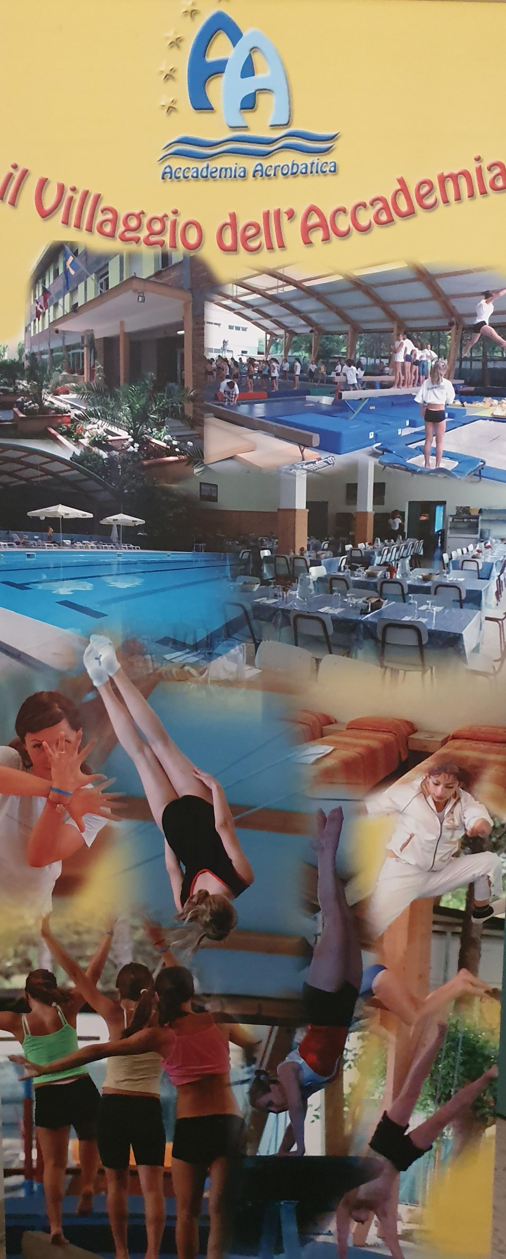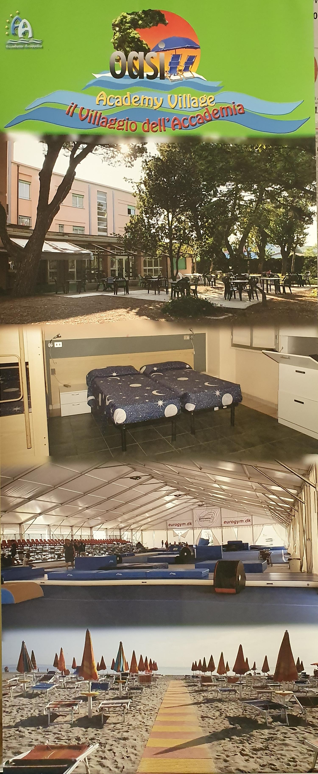
GENERAL INFORMATION

COMPETITION ORGANIZERS | FISAC – FEDERAZIONE ITALIANA SPORT ACROBATICI E COREOGRAFICI  Viale. Cristoforo Colombo 18  47042 Cesenatico  direzione@villaggioaccademia.it ( Accomodation Info )  cesare.yankov@fisacgym.it ( Competition Info )
LOCATION | CESENATICO - ITALIA
DATES | From 14 APRIL to 18 APRIL 2022
VENUE | 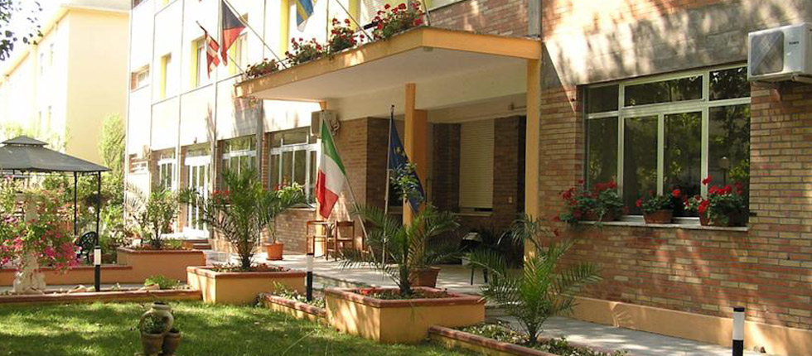  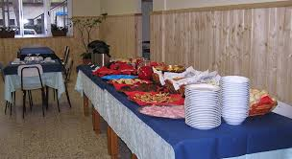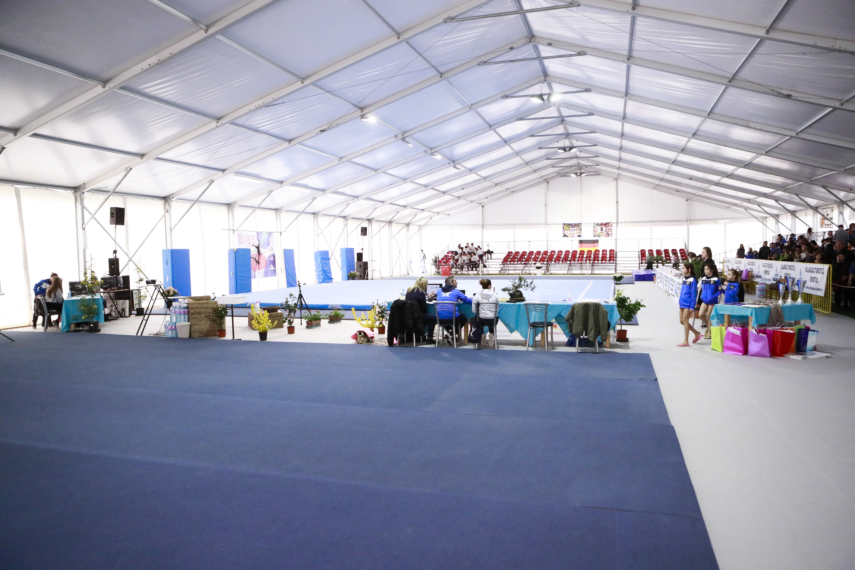  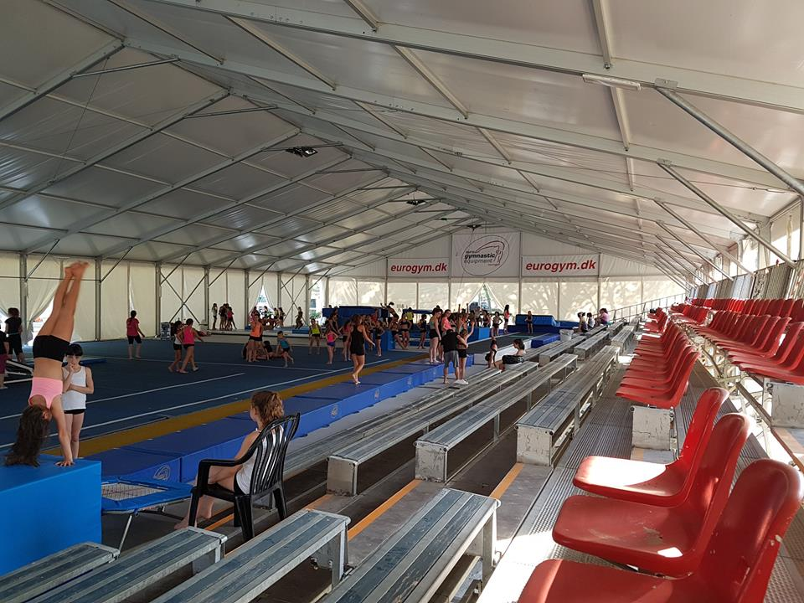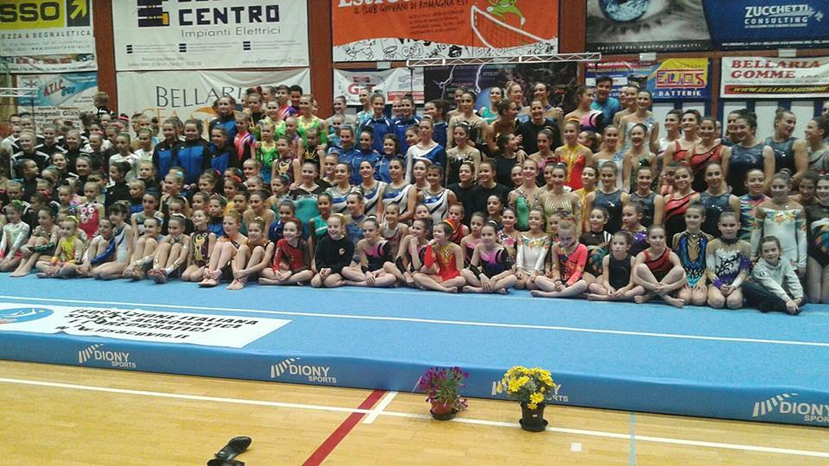
REGISTRATION DEADLINES | The price for the stay for careers always at the quarters is 37 € with the full pension treatment (drinks included).  The price for the stay (full pension) at the Acrobatic academy quarters for athletes and technicians is 37 € per day included also with transportation to and from the Station of Cesenatico  The accommodation payment and transfer must be made within 12 March 2022 by bank transfer to the following account:  CREDITO COPERATIVO ROMAGNOLO  ACCADEMIA ACROBATICA SRL  IBAN: IT79P0707024000010000847348  C/C Numero: 10-000847348  BIC: ICRAITRRTQO  Reason for Payment: (Name of the Club and number of full delegation)  IMPORTANT / ACCOMODATION / TRANSFER /  For more organizational and logistical information you can call the following numbers:  FISAC Secretary and Presidency  +39 380 2982176 - 0547-84935 and ask for Franca  franca.casadei@fisacgym.it  For more technical information:  National Technical Direction - Lachezar Cesare Yankov  +39 348 3814080  cesarebg@live.it / cesare.yankov@fisacgym.it
Judges | You are expected to provide at least 1 judge, however if you have more than 1 judge available their attendance would be greatly appreciated. A 100 € fee will be charged if no judge is supplied.
ENTRY FEE  Training end Competition  Categories | The price of free training before or after the competition is 10 € for athlete. (Full training, use structures and tools of the Federation FISAC)  Entry to the competition is 25 € for Athlete. (C1, C2, Youth)  Podest – individual international discipline 15 € for Athlete.  Entry to the competition is 35 € for Athlete. (B, Age Group, Senior)
VISA | If you need an official invitation to obtain a visa to travel to Italy, please contact us as soon as possible, no later than 01 of December 2021 (please, fill the necessary documents).
INSURANCE | The organizer is not responsible for any liability in the case of accidents.  Therefore, all participants are advised to look for adequate insurance coverage.
Local Transfer  INTERNATIONAL TRANSPORTATION | Free transport from and to the Station of Cesenatico.  Bologna Airport for groups of at least 8 people is 20€ each way. 40€ in total from and to Bologna Airport.  For groups less than 8 people price still to decide. Arrivals to other Airports still to calculate.
ACCOMODATION end Special Offers for Clubs | Every Club with more than 10 registered Athletes at the Championship and at the Training (both) will have a complimentary stay for 1 Technician and 1 judge for the entire period. (From 15 athletes end mor – 1 coach 50% discount)  Every Club with less than 10 registered Athletes will have a complimentary stay for 1 Judge for the entire period. (Not less than 5 athletes)
FINAL BANQUET | Saturday, the 16 April 2022
PROVISIONAL SCHEDULE | Thursday – 14 APRIL  Arrival of Delegations and accommodation. Training in Academy. Technical meeting for the judges and coaches.  Thursday - 14 / Friday 15 APRIL  Training in Academy. Full training, use structures and tools of the Federation FISAC  Saturday, 16 APRIL  Opening ceremony  Competition  Banquet – Farewell party for al.  Sunday 17 April  Competition  Gala performances (To be defined)  Awards Ceremony / Departure of the delegations  Monday 18 April - only National Championships  C3, Appoggi – National Category  Podest – International Category - (To be defined by registration)
GALA Farewell Party | We welcome any delegation to participate in the Gala performance, which will take place before the awarding ceremony on Friday 15 April. Please, inform us about your gala performance in your registration.
AWARDS | ACRO  You can take part with more pairs and groups per category, but only one of them per club per category Age 11-16/12-18/13-19/Seniors will take part on the final (those who has the best score). The organizers can take part with more gymnasts from club per category, but only 2 of them can be rank.  Individual all around (for each category)  First 3 positions will be award with medal: Gold-Silver-Bronze.  CUP: Team Competition  For all participating athletes in all categories - participation medal.  International Acrobatic Cup 2022 Ranking and Prices  The Following Rules are only for the TWO competitions  Mainz (GER) 2021 Cesenatico (IT) 2022  Ranking  Results: In all the compositions and categories are admitted to the final classification only combinations that have participated in at least 2 steps of the International Cup and the classification will be drawn up taking into account the sum of the two best steps more the “Bonus”.  Prizes: The prizes are at the discretion of the individual stages of O.C. of each step. The final classification of awards is offered by the "Village Academy" with any other prizes offered by other sponsors.  Prizes: The prizes are at the discretion of the individual stages of O.C. of each step. The final classification of awards is offered by the "Village Academy" with any other prizes offered by other sponsors.  Prizes  • 1 ° place, one-week stay at the A.V. (Academy Village- Cesenatico- Italy) + 1 coaches, completely free.  • At the 2nd one-week stay at the A.V. + 1 coaches, with 50% discount.  • At the 3rd, one-week stay at the A.V. + 1 coaches, with 30% discount.  *Prizes will include 10 athletes + 1 coaches  The above conditions will be valid only if in the final rankings will be 3 or more combinations in each category.  Sponsored by:
BANK ACCOUNT INFORMATION  Technical Information for Championship al Category | Payments must be pay as follows:  The accommodation payment and transfer must be made within 12 of Match 2022 by bank transfer to the following account:  CREDITO COPERATIVO ROMAGNOLO  ACCADEMIA ACROBATICA SRL  IBAN: IT79P0707024000010000847348  C/C Numero: 10-000847348  BIC: ICRAITRRTQO  Reason for Payment: (Name of the Club and number of persons.)  Tariff Sheet – Saturday 19 March 2022  acrocupfisac@gmail.com  Musik – Saturday 26 March 2022  acromusicfisac@gmail.com
DEADLINES SUMMARY | DEFINITIVE REGISTRATION Saturday 05 March 2022  VISA REQUEST FORM Tuesday 01 December 2021 - Definitive  NOMINATIVE REGISTRATION Saturday 05 February 2022 - Provisional (Declaration of interest end name of Clubs) (Names of gymnast, category, judges)  TRAVEL SCHEDULE FORM Saturday 12 March (Declaration of interest end name of Clubs) (Names of gymnast, category, judges)  ACCOMODATION FORM Saturday 12 March (Declaration of interest end name of Clubs) (Names of gymnast, category, judges)  PAYMENT OF THE ENTRY FEE Training and entry the competition, you pay in Acrobatic Academy Friday 14/04/2022  PAYMENT OF ACCOMODATION Saturday 12 March

TECHICAL INFORMAZION
FOR REQUIRIMENTS

GERMAN, BULGARO, RUSSO – g.kiryakov@gmax.net /

ITALIANO, RUSSO, BULGARO, POLACO – cesarebg@live.it cesare.yankov@fisacgym.it

TECHNICAL REQUIREMENTS
ACROBATIC GYMNASTICS

For Open Group International Cup for Club
Group C1 / C2 – Combined
Youth Groups
Group B – Static, Dynamic
Podest – Individual W/M (C1, C2, B, Master)
Age Group / 08-16 / 11-18 /12-19 / Seniors

Group C  C1 / 6 – 13 anni  C2 / 8 - 19 anni | Requisiti  Minimi: | Requisiti Speciali: | Composizione dell’esercizio
Combinato  2.30  È AMMESSA LA MUSICA CON LE PAROLE | 1 elemento Statico – categoria 1  1 elemento Statico – categoria 2  1 elemento Statico – categoria 3  3 elementi dinamici.  3 elementi  Individuali  1 elemento Categoria 1  1 elemento  Categoria 2  Il 3° elemento Libero. | 1 elemento di presa (elementi dinamici G)  Maximum 2 arrivi a terra (Dismounts) dal Partner.  Totale 5 arrivi a terra  Maximum 3 posizioni di partenze e prese uguali.  Statici:  Il top un elemento uguale maximum 2 volte – Posizione Statica e 2 volte in transizione della base. | Referente codice FISAC.  Maximum 8 elementi (minimo 6 elementi) di gruppo e 3 elementi individuali.  Il terzo elemento individuale – libero - dalle categorie 1 o 2.  Differenza tra elementi statici e dinamici 50%.  Difficoltà 60 = 0,6 Massimo  + 10 Tolleranza.  Coppie: La base NON può ripetere la stessa posizione  Gruppo: se la Top e la Mezzana, sono nella stessa posizione si conta una sola volta (es.: due squadre valgono come una)

CRUPPO  Youth  8 – 16 anni | Requisiti  Minimi obbligatori | Requisiti  Speciali | Composizione dell’Esercizio
Combinato  2.30  Nessuna differenza di età tra partner.  È AMMESSA LA MUSICA CON LE PAROLE | Coppia  3 elementi statici, 2 dalle Age Group – Junior Rules  1 dal TOD con valore 1-9  3 elementi dinamici  2 dalle Age Group – Junior Rules  1 dal TOD con valore 1-14  3 elementi Individuali  Gruppo.  2 piramidi statici  1 deve essere scelta dal Age Group – Junior Rules  1 deve essere scelta dal TOD con valore 1-16  3 elementi dinamici  2 scelti dal Age Group Rules  1 deve essere scelto dal TOD con valore 1-14  3 elementi individuali | Elementi Individuali:  Flexibility /Balance / Agility  *Salto NON è obbligatorio.  Elementi Opzionali:  Coppia Statico 1-9  Dinamico 1-14  Gruppo Opzionali:  Statico 1-16  Dinamico 1-14 | Referent code. Age Group / Junior Rules  Nessun limite di partenze e arrivi uguali.  Difficulty max. D – Value of Compulsory Elements 0,5

Group B  Coppie / Pairs | Requisiti  Minimi: | Requisiti  Speciali: | Pairs  Balance
Statico 2.30  Max. 80V + 10 T  AGE 12 - 18  Senza limiti di età tra le partner.  Età minima otto anni (per la top) | * COPPIE  *Minimo: 5 elementi, con minimo 3 posizioni da 3”  *Tutti gli elementi devono avere difficoltà minima V1.  * Una transizione obbligatoria della Top esempio:  (Squadra – coccodrillo)  (In piedi – discesa in spaccata della base)  * NON è obbligatoria la verticale (per la top) e il Salto per elementi individuali per tutti. | *Maximum 8 elementi di coppia.  Una posizione statica per la top può essere ripetuta max. 4 volte. (Ad esempio: la verticale 2 volte in posizione statica e 2 volte con transizione della base).  * Maximum 3 elementi individuali per la difficolta V categoria 1.  Flessibilità, Balance, Agilità  *Valgono Tutti i Requisiti Speciali per esercizi STATICI in Vigore FIG:  Age Group 12-18 | O at least 5 partner elements with a minimum of 3 static positions with 3” stop by the top. Maximal 8 Partner elements.  O at least 1 motion by the top or the base  O at least 3 individually elements of category 1  Special requirements:  • an individually somersault or back flip is not required  • a handstand of the top is not required  • There are all the other restrictions of the World
* la categoria B -  Gruppo / Group  Possono eseguire anche solo un esercizio a scelta tra statico o dinamico.  Classifica separata.  (NON C’E’ LA SOMMA DEI PUNTEGGI PER ESERCIZIO STATICO E DINAMICO)  È AMMESSA LA MUSICA CON LE PAROLE (solo in un esercizio – statico o dinamico) | GRUPPO/GROUPS  *Minimo 2 piramidi separate da diverse categorie, con 3 posizione statiche tenute 3” ognuna.  * Obbligatoria una Motion, Transizione (esempio: squadra, coccodrillo.)  * NON è obbligatoria la verticale (per la top sulla piramide) | *Maximum 4 piramidi separate in un esercizio di diverse categorie.  *La difficoltà per la transizione si prende quando da una posa statica x 3” si va ad un’altra posa statica x 3”  *La Top può ricevere la difficoltà per la stessa posizione in una combinazione:  * 2 volte per la statica  * 2 volte per la transizione  *Maximum 3 elementi individuali per la difficolta V. Categoria 1.  Valgono Tutti i Requisiti Speciali per gli esercizi STATICI in Vigore FIG  Age Group 12-18 | GROUPS  O at least 2 single pyramids of different categories with a minimum of 3 static positions with  3” stop by the top  O A maximum of 4 pyramids, all different categories  O at least 1 motion by the top  O at least 3 individually elements by category 1  Special requirements:  • an individually somersault or back flip is not required  • a handstand of the top is not required  • There are all the other restrictions of the World Age Group Competition Rules 12-18.
Dinamico  2.00 | Requisiti  Minimi: | Requisiti  Speciali: | DYNAMIC  2,00”  basic requirements:
Coppie /Gruppi  Max. 70V + 10T  AGE 12 – 18  Senza limiti di età tra le partner.  Età minima 8 anni (per la top) | *Minimo 5 elementi Dinamici con fase di Volo.  * Due 2 dei quali con ripresa del partner.  *Max. 3 arrivi a terra (dal partner a terra)  *Tutti gli elementi devono avere difficoltà minima V1.  * NON e obbligatorio Salto per gli elementi di gruppo e coppie, come anche per gli elementi individuali. | *Maximum 8 elementi di gruppo per difficolta V.  *Minimum 2 e max. 3 elementi individuali per la difficoltà V Categoria 2.  *Valgono Tutti i Requisiti Speciali per gli esercizi STATICI in Vigore FIG  Age Group 12-18 | • at least 5, maximum of 8 partner elements, from that  O at least 2 elements to the partner and  O maximum 3 bounces (from partner to the floor)  o at least 2 individually elements of the category 2  Special requirements:  • an individually somersault or back flip is not required  • There are all the other restrictions of the World Age Group Competition Rules 12-18.

Podest  2,30 | Requisiti  Minimi: | Requisiti  Speciali: | Composizione dell’esercizio
Disciplina  Individuale.  W/ M  Esercizio Combinato.  Elementi di verticali e posizioni di equilibrio in varie forme, eseguiti su un tavolino di verticalismo.  Esercizio coreografato. | Allieve: “C  C1 - (6 – 13)  C2 - (14 - 19)  *Difficolta massima 50V.  - (va divisa x 100 / = 0,50)  Junior: “B” Classe  (NON limite d’età)  * Difficolta massima 70 V – (va divisa x 100 /= 0,70)  Master Class:  Nessun limite d’età ma segue il programma 12-19 FIG Combinato  * Difficolta massima 80 V – (divisa x 100 /= 0,80  * Tolleranza + 20 V | Allieve e Junior  3 Elementi Statici  3 Elementi Dinamici con 360°  Individuali: Max. 3  1 categoria / uno  1 categoria / due  1 Libero  Elementi da codice FISAC  Junior: B  Minimo 6 Massimo 8 Elementi Statici  Da diverse categorie:  1-verticale pag.5  1-squadra o coccodrillo pag.6  1-equilibrio pag.7  Minimo 3 elementi Dinamici con giro 360°  Individuali: Max 3  1 categoria / uno  1 categoria / due  1 Libero  Elementi da Codice FIG TOD.  Master Class  Minimo 6 Massimo 8  3 Elementi Statici di Diverse categorie  3 Elementi Dinamici con 360° di giro  Individuali: (max. 3)  1 categoria / uno  2 categoria / uno  1 Libero  Elementi da Codice FIG TOD. | Allieve e Junior  *1 discesa con valore per la difficolta (NON è obbligatoria)  * Elementi statici possono essere ripetuti come Dinamici con 360°  * Verticale, Flick e Salto NON sono obbligatori.  Junior: B  * Elementi statici possono essere ripetuti come Dinamici con 360°  *Obbligatoria 1 discesa con Valore – pag.8  * Salto come elemento individuale NON è Obbligatorio.  Master Class  *Obbligatori 2 verticali da 2 categorie diverse A/B/C/D/E pag.1 Podest  *Maximum 4 elementi. Eseguiti in serie, statici e dinamici possono essere collegati.  *Obbligatoria 1 discesa con Valore – pag.8  *Salto come elemento individuale E Obbligatorio.  * Elementi statici possono essere ripetuti come Dinamici con 360°

TECHNICAL REQUIREMENTS
ACROBATIC GYMNASTICS
Age Group 08-16/11-18/12-19/ Senior
FIG
(Aggiornamento Newsletter - FIG)

AGE GROUPS | QUALIFICATIONS | FINALS | COMPOSITION OF EXERCISES
08-16 | Each pair and group present one Balance and one Dynamic exercise.  The exercise is composed of compulsory and optional elements. The performance order is set by draw.  Ranking after the qualifications is determined by the sum of scores from the two Exercises: Balance and Dynamic.  The top 8 proceed to a Final with not more than one from each club in each category.  Competitors cannot participate in the Final without competing in both Balance and Dynamic qualifying events. | Marking starts from Zero.  In the final, pairs and groups will present one exercise:  Women’s Pairs: Balance  Mixed Pairs: Dynamic  Men’s Pairs: Balance  Women’s Groups: Dynamic  Men’s Groups: Balance  The reverse standing of the sum sets the performance order in the Final from both Balance and Dynamic exercises. | According to FIG Rules for  Age Group 11-16  Difference of Age max. 6 years
11-18 | Each pair and group present one Balance and one Dynamic exercise. The performance order is set by draw.  Ranking after the qualifications is determined by the sum of scores from the two exercises: Balance and Dynamic.  The top 8 proceed to a Final with not more than one from each club in each category.  Competitors cannot participate in the Final without competing in both Balance and Dynamic qualifying events. | Each Pair and group perform one Combined exercise in the finals.  Marking starts from zero.  The performance order in the Final is set by the reverse standing of the sum from both Balance and Dynamic exercises. | According to FIG Rules for  Age Group 12-18  Difference of Age max. 6 years
12-19 | Each pair and group present one Balance and one Dynamic exercise.  The performance order is set by draw.  Ranking after the qualifications is determined by the sum of scores from the two Exercises: Balance and Dynamic.  The top 8 proceed to the Final with not more than one from each club in each category.  Competitors cannot participate in the Final without competing in both Balance and Dynamic qualifying events. | Each Pair and group perform one Combined exercise in the finals.  Marking starts from zero.  The performance order in the Final is set by the reverse standing of the sum from both Balance and Dynamic exercises. | According to FIG Rules for  Age Group 13-19  Difference of Age max. 6 years
Senior  + 13 | Each pair and group present one Balance and one Dynamic exercise.  The performance order is set by draw.  Ranking after the qualifications is determined by the sum of scores from the two Exercises: Balance and Dynamic.  The top 8 proceed to the Final with not more than one from each club in each category.  Competitors cannot participate in the Final without competing in both Balance and Dynamic qualifying events. | Each Pair and group perform one Combined exercise in the finals.  Marking starts from zero.  The reverse standing of the sum sets the performance order in the Final from both Balance and Dynamic exercises. | According to FIG  Rules for  Senior

