International Training 2021
National Championship FISAC 2021
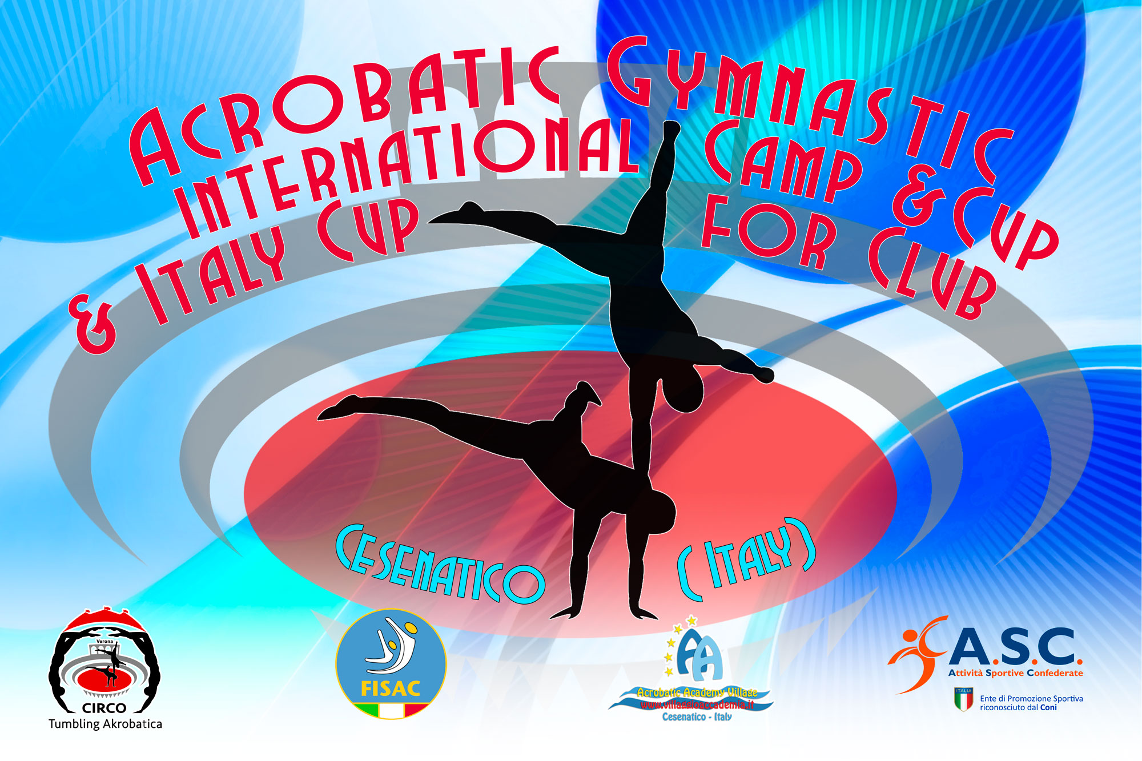
7° International Acrobatic Cup for Clubs 2021

Form to be send to
Organizing Committee
FISAC – FEDERAZIONE ITALIANA SPORT ACROBATICI E COREOGRAFICI
Viale. Cristoforo Colombo 18
47042 Cesenatico
direzione@villaggioaccademia.it
cesarebg@live.it
Deadline:
SATURDAY 16 January 2021 (provisional)
SATURDAY 20 February 2021 (Definitive)

ACCOMMODATION FORM

Club/Country |  | Contact person:
 |  | Phone number:
 |  | E-mail:

Last Name, First Name |  | Function | Arrival Date | Departure Date | Price for 3 Days | Extra Nights  Price | TOTAL
1.
2.
3.
4.
5.
6.
7.
8.
9.
10.
11.
12.
13.
14.
15.
16.
17.
18.
19.
20.
 |  |  |  |  | Total:
ENTRY FEE | № of gymnasts |  | 37 € |  | Total:
INT. TRANSFER | № of persons |  | 37 € |  | Total:
 |  |  |  |  | GRAND TOTAL:
Place and date:

