International Training 2019 Championship FISAC 2019
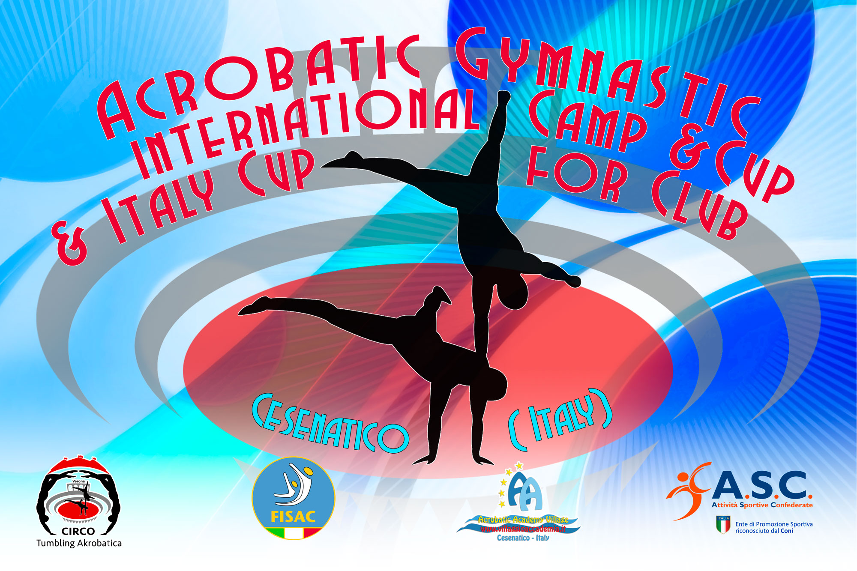
5° International Acrobatic Cup for Clubs2018

Form to be send to
Organizing Committee
FISAC – FEDERAZIONE ITALIANA SPORT ACROBATICI E COREOGRAFICI
Viale. Cristoforo Colombo 35
47042 Cesenatico
direzione@villaggioaccademia.it
cesarebg@live.it
Definitive: Saturday 09 March 2019
Definitive - NOMINATIVE REGISTRATION

Club/Country |  | Contact Person :
 |  | Phone nombre :
 |  | E-mail :
Category: C1 (6-14) / C2 (- 19) / Podest / B2 / Age: 08 -16
11 – 18 / 12 – 19 / Senior.
Last Name, First Name |  | Category | WP | MP | Mix P | WG | MG | C | J
Total Gymnasts:
Total Coaches:
Total Judges:

Place and date:

