TeamGym International Cup for Clubs 2018

Dates and Venues:

28 April Czech Republic – Prague
mail : cgf@gymfed.cz

12 May Austria - Dornbirn
email : marieluise.kogler@A1.net

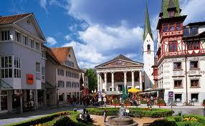

19-20 May Scotland – Dundee
email : donna2gym@hotmail.co.uk

09-10 June Italy - Cesenatico
mail : direzione@villaggioaccademia.it

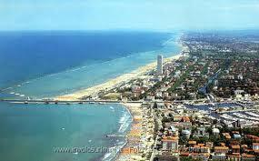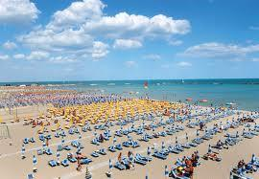

29-30 September ENGLAND - Bracknell
email : peter@bracknellgymnasticsclub.co.uk

24 November Spain – Gran Canaria
email : jesus.telo@online.de

Sponsored by:

Web site : www.villaggioaccademia.it
Mail : direzione@villaggioaccademia.it

