International Training Camp 2018
National Championship FISAC 2018
4° International Acrobatic Cup for Clubs 2018

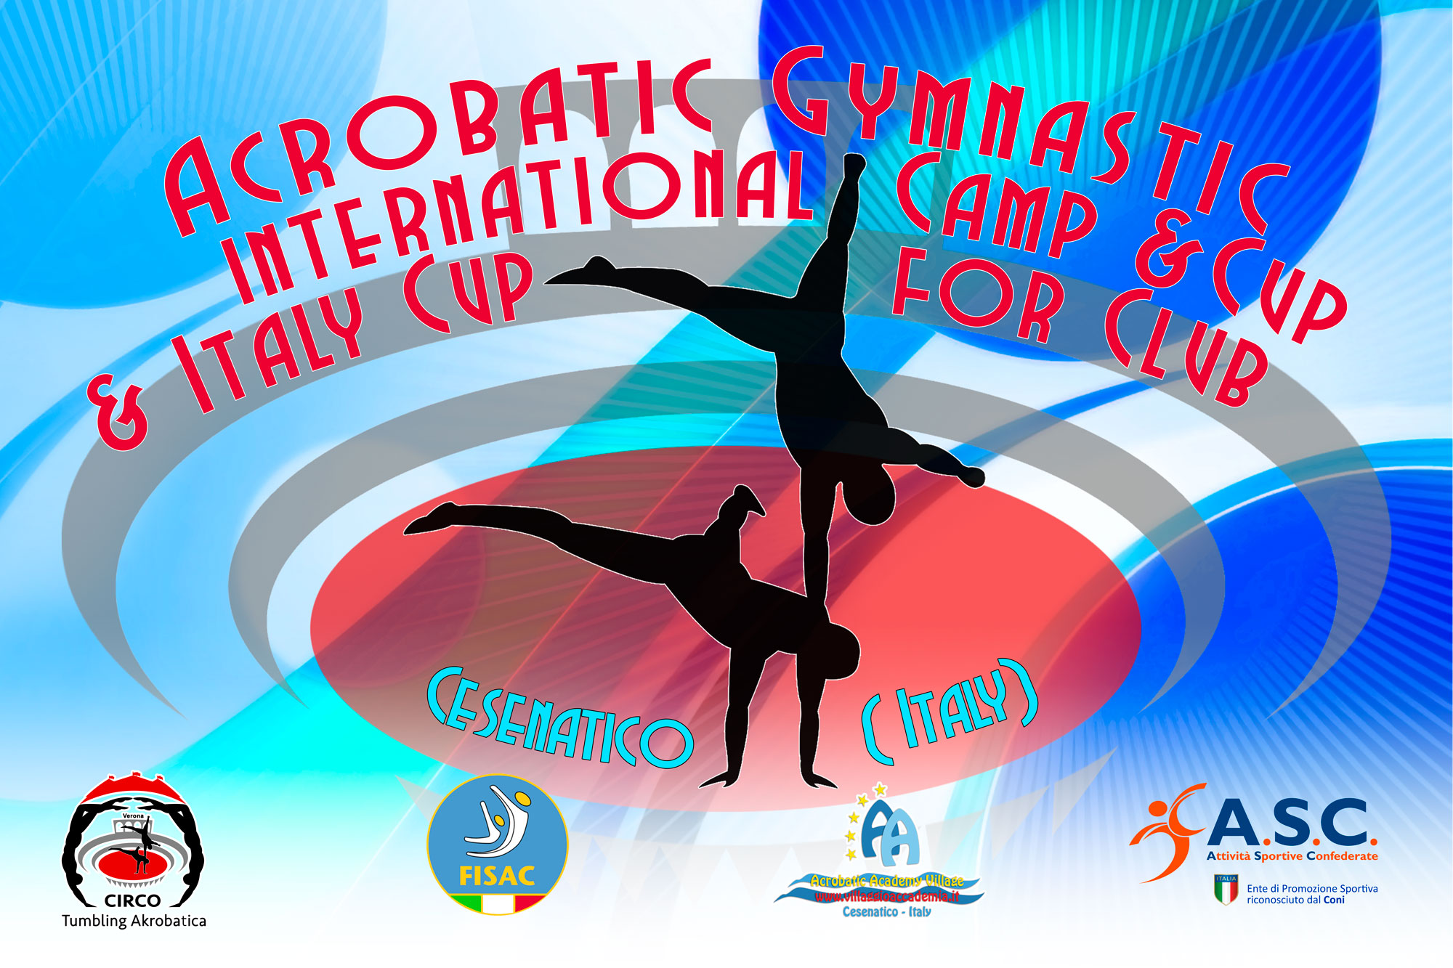
CESENATICO ITALIA
March /April 2018
- International Training Camp 29-30/03
- FISAC 4 ° National Championship 31-01
- 4 ° International cup for clubs 31-01/ 04

FISAC has as its goal the development and diffusion of Acrobatics in Italy and Europe and after the success of the International Team gym Cup to which 15 countries now participate with over 70 Teams, has also set the International Acrobatic Cup.
At the Last Edition in 2017 over 300 Athletes from different clubs and nations have participated like Bulgaria, Germany, Moldova, Hungary, Portugal, England, Puerto Rico, and Italy.

With the collaboration of the Acrobatic Academy of Cesenatico, Federal National Technical Head Quartier, FISAC will offer at the participants a substantial economic help to this international competition and at the NATIONAL CHAMPIONSHIPS 2018!

FISAC NATIONAL ACROBATIC CHAMPIONSHIPS will be open to all Clubs (Sport Clubs) which will request them, from any other Federations and/or Sport Promotion Association. FISAC membership is COMPLETELY FREE for the first year and in this way, it will give CONSIDERABLE FACILITY!

GENERAL INFORMATION

COMPETITION ORGANIZERS | FISAC – FEDERAZIONE ITALIANA SPORT ACROBATICI E COREOGRAFICI  Viale. Cristoforo Colombo 35  47042 Cesenatico  direzione@villaggioaccademia.it  cesarebg@live.it cesare.yankov@fisacgym.it
LOCATION | CESENATICO / BELLARIA / ITALIA
DATES | From 29th March, to 03th APRIL 2017
VENUE | 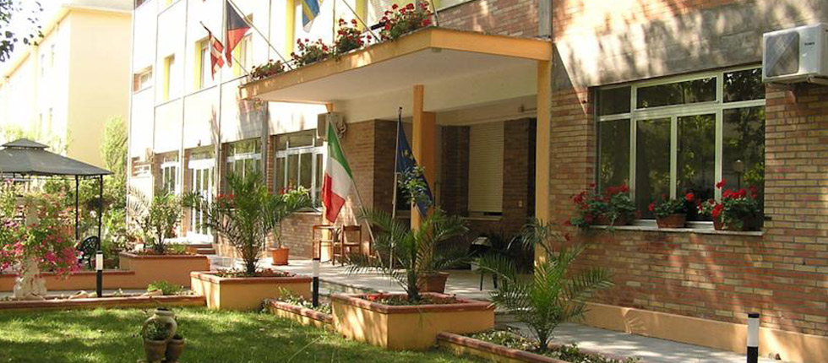  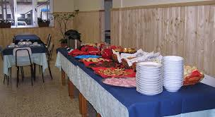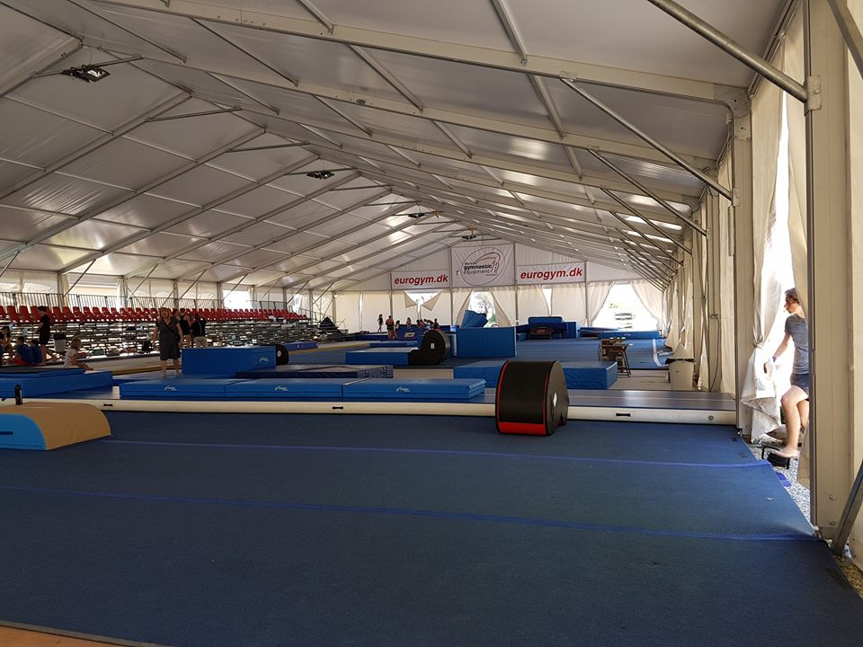  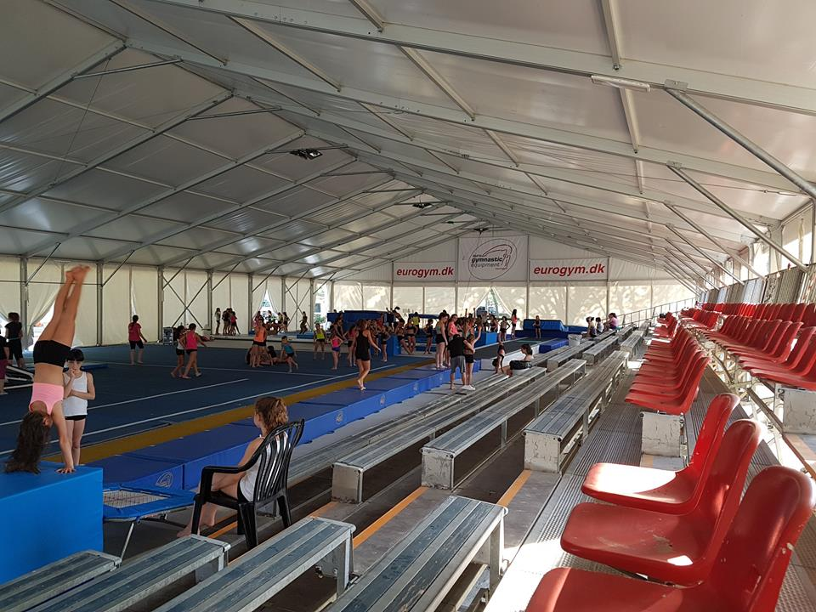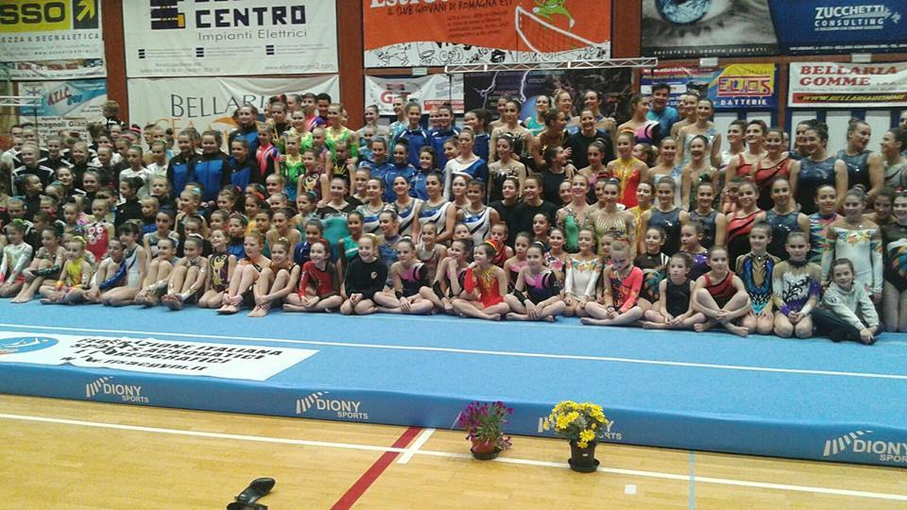
DELEGATIONS  End Categories | ACRO Categories / Number of combinations /  Age Group WP MP MxP WG MG Individual Podest  11-16  12-18  13-19  Seniors +13  Coach  Judge  C1 / 6-14  C2 / - 19  B1 - open  Combined  B2 - open  Balance  Dynamic  Podest
REGISTRATION DEADLINES | The price for the stay for careers always at the quarters is 35€ with the full pension treatment (drinks included).  The price for the stay (full pension) at the Acrobatic academy quarters for athletes and technicians is 35€ per day included also with transportation to and from the Station of Cesenatico  The accommodation payment and transfer has to be made within Saturday 10 March 2018 by bank transfer to the following account:  CREDITO COPERATIVO ROMAGNOLO  ACCADEMIA ACROBATICA SRL  IBAN: IT79P0707024000010000847348  C/C Numero : 10-000847348  BIC: ICRAITRRTQO  Reason for Payment: (Name of the Club and number of full delegation )  IMPORTANT / ACCOMODATION.  For more organizational and logistical information you can call the following numbers:  FISAC Secretary and Presidency  +39 380 2982176 - 0547-84935 and ask for Franca  franca.casadei@fisacgym.it  For more Technical information:  National Technical Direction - Lachezar Cesare Yankov  +39 348 3814080  cesarebg@live.it cesare.yankov@fisacgym.it
ENTRY FEE | The price of the camp previously to the competition is 15€ per athlete (Full training Camp, use structures end tools and coaches of the Federation FISAC ), for those who will participate at the National Championship and the International Cup for Clubs For Those who will NOT participate in the Competition, the price will be 30 € ( full training camp, use structures end tools and coaches of the Federation FISAC )  Entry to the competition is 10€ for Athlete. (For all categories.)  Training Camp and competition, you pay in Acrobatic Academy.
VISA | If you need an official invitation to obtain a visa to travel to Italy , please contact us as soon as possible, no later than 18 ^{th} of December 2017 (please, fill the necessary documents).
INSURANCE | The organiser is not responsible for any liability in the case of accidents.  Therefore, all participants are advised to look for adequate insurance coverage.
INTERNATIONAL TRANSPORTATION | Free transport from and to the Station of Cesenatico. Bologna Airport for groups of at least 8 people is 20€ each way. 40€ in total from and to Bologna Airport. For groups less than 8 people price still to decide. Arrivals to other Airports still to calculate.
LOCAL  TRANSPORTATION | The price for the stay (full pension) at the Acrobatic academy quarters for athletes and technicians is 35€ per day included also with transportation to and from the Station of Cesenatico
ACCOMODATION  end Special Offers for Clubs | Every Club with more than 10 registered Athletes at the Championship and at the Training Camp will have a complimentary stay for 1 Technician and 1 judge for the entire period.  Every Club with less than 10 registered Athletes will have a complimentary stay for 1 Judge for the entire period.
FINAL BANQUET | Saturday, the 31th March 2018
PROVISIONAL SCHEDULE | Thursday, 29th March  Arrival of Delegations and accommodation. Training Camp in Academy. Technical meeting for the judges and coaches.  Friday , 30 March  Training Camp in Academy.  Saturday, 31th March  Opening ceremony  Competition  Banquet  Sunday 01th April  Competition  Gala performances  Awards Ceremony  Farewell party  Monday 02th end 03 April  Excursion to Cesenatico / Departure of the delegations
GALA | We welcome any delegation to participate in the Gala performance which will take place before the awarding ceremony on March 30 th. Please, inform us about your gala performance in your registration.
AWARDS | ACRO  You can take part with more pairs and groups per category, but only one of them per club per category Age 11-16:12-18:13-19:Seniores will take part on the final (those who has the best score).The organizers can take part with more gymnasts from club per category, but only 2 of them can be rank.  Individual all around (for each category)  First 3 positions will be award with medal: Gold-Silver-Bronze.  Certificate : Every Participant  CUP: Team Competition  TEAM COMPETITION – Mainz (GER) and Cesenatico (IT)  International Acrobatic Cup 2017-2018 Ranking and Prices  The Following Rules are only for the TWO competitions  Mainz (GER) and Cesenatico (IT)  Ranking  Final Results: In all the compositions and categories are admitted to the final classification only combinations that have participated in at least 2 steps of the International Cup and the classification will be drawn up taking into account the sum of the two best steps more the “Bonus”.  Prizes: The prizes are at the discretion of the individual stages of O.C. of each step. The final classification of awards are offered by the "Village Academy" with any other prizes offered by other sponsors.  Prizes: The prizes are at the discretion of the individual stages of O.C. of each step. The final classification of awards are offered by the "Village Academy" with any other prizes offered by other sponsors.  Prizes  • 1 ° place, one-week stay at the A.V. (Academy Village- Cesenatico- Italy) + 1 coaches, completely free.  • At the 2nd one-week stay at the A.V. + 1 coaches, with 50% discount.  • At the 3rd, one-week stay at the A.V. + 1 coaches, with 30% discount.  *Prizes will include 9 athletes + 1 coach  The above conditions will be valid only if in the final rankings will be 3 or more combinations in each categories.  Sponsored by:
BANK ACCOUNT INFORMATION | Payments must be payd as follows:  The accommodation payment and transfer has to be made within Saturday 10 March 2018 by bank transfer to the following account:  CREDITO COPERATIVO ROMAGNOLO  ACCADEMIA ACROBATICA SRL  IBAN: IT79P0707024000010000847348  C/C Numero : 10-000847348  BIC: ICRAITRRTQO  Reason for Payment: (Name of the Club and number of person.)
DEADLINES SUMMARY | DEFINITIVE REGISTRATION Saturday 3 February 2018  VISA REQUEST FORM Saturday 18 December 2018 - Definitive  NOMINATIVE REGISTRATION Saturday 13 January 2018 - Provisional ( Declaration of interest end name of Clubs ) Saturday 03 February 2018 – Definitive ( names of gymnast, category , judges )  TRAVEL SCHEDULE FORM Saturday 13 January 2018 - Provisional ( Declaration of interest end name of Clubs ) Saturday 03 February 2018 – Definitive ( names of gymnast, category , judges )  ACCOMODATION FORM Saturday 13 January 2018 - Provisional ( Declaration of interest end name of Clubs ) Saturday 03 February 2018 – Definitive ( names of gymnast, category , judges )  PAYMENT OF THE ENTRY FEE Camp and competition you pay in Acrobatic Academy.  PAYMENT OF ACCOMODATION Saturday 10 March 2018 – Definitive

TECHICAL INFORMAZION
FOR REQUIRIMENTS

TEDESCO – g.kiryakov@gmax.net / mgraw@gmax.net
INGLESE – zdravko.velikov70@gmail.com
ITALIANO, RUSSO, BILGARO, POLACO – cesarebg@live.it cesare.yankov@fisacgym.it
TECHNICAL REQUIREMENTS
ACROBATIC GYMNASTICS
For Open Group
Group C1 / C2 – Combined
Group B1 – Combined (Age 12 – 18)
Group B2 – Static, Dynamic (Age 12 – 18)
Podest – Individual

Group C  C1 / 6 – 14 anni  C2 / fino 19 anni | Requisiti  Minimi: | Requisiti Speciali: | Composizione del esercizio
Combinato  2.30 | 1 elemento Statico – categoria 1  1 elemento Statico – categoria 2  1 elemento Statico – categoria 3  3 elementi dinamici.  3 elementi individuali  1 elemento individuale – categoria. 1  1 elemento individuale – categoria. 2 | Dinamico:  1 elemento di presa  Dal partner  Maximum 2 arrivi a terra per la V.  Maximum 3 posizioni di partenze e prese uguali.  Statici:  Il top un elemento uguale maximum 2 volte, di cui 1 volta in movimento dalla base.  La base solo una transizione, dà su verso giù. | Referente codice DSAB.  Maximum 8 elementi (minimo 6 elementi) di gruppo e 3 elementi individuali per la difficoltà.  Il terzo elemento individuale – libera scelta dalle categorie 1 o 2.  Differenza tra elementi statici e dinamici 50%.  Difficoltà 80 = 0,8 Massimo
Group B1  Combinato 2.30  Max. 80 V | Requisiti  Minimi: | Requisiti  Speciali: | Composizione del esercizio
Senza limiti d età tra le partner.  Età minima 08 anni (per la top) | Minimo: 6 elementi di gruppo e coppie.  3 devono essere posizioni statiche con 3” di tenuta, di cui almeno una con transizione della TOP. (Esempio: Squadra-coccodrillo)  E 3 elementi dinamici; è  Obbligatorio un elemento di ripresa del partner.  Tutti gli elementi devono avere difficoltà minimo V1.  * NON è obbligatoria la verticale (per la top sulla piramide) e Salto per elementi individuali per tutti. | Maximum 8 elementi di gruppo e coppie.  Maximum 3 elementi individuali per la difficoltà V.  1 della - 1 categoria  1 della - 2 categoria  Il 3 elemento libero –di 1 o di 2 categoria.  Valgono Tutti i Requisiti Speciali per esercizi COMBINATI in Vigore FIG  Age Group 12-18  * NON più di 2 arrivi a terra per la Difficoltà. | www.svr-acro.de  www.fisacgym.it  In vigore tutti limiti del codice FIG per esercizi Combinati.  Il valore degli elementi statici non potrà superare la doppia somma degli  Elementi dinamici e viceversa.

Group B2  Coppie / Pairs | Requisiti  Minimi: | Requisiti  Speciali: | Composizione del esercizio
Statico 2.30  Max. 80 V  AGE 12 - 18  Senza limiti di età tra le partner.  Età minima 8 anni (per la top) | * COPPIE / PAIRS:  Minimo: 5 elementi.  Tutti gli elementi devono avere difficoltà minima V1.  * Una transizione obbligatoria della Top esempio:  (Squadra – coccodrillo)  (In piedi – discesa in spaccata della base)  * NON è obbligatoria la verticale (per la top) e Salto per elementi individuali per tutti. | Maximum 8 elementi di coppie.  Una posizione statica per la top, può essere ripetuta max. 4 volte. (Ad esempio: la verticale 2 volte in posizione statica e 2 volte con transizione della base).  Maximum 3 elementi individuali per la difficolta V categoria 1.  Flexibility, Balance, Agility  Valgono Tutti i Requisiti Speciali per esercizi STATICI in Vigore FIG:  Age Group 12-18 | www.svr-akro.de  www.fisacgym.it  Clarifications for Pairs:  Definition of an element of difficulty:  See appendix 6  ▪ Static Hold of the Top + Base position  ▪ Mount (including the static position of the top and the base)  ▪ Motion of the Top + Static Hold of the Top+ Base position  ▪ Start position of the Top + Motion of the Base + Static Hold of the Top + Base position  ▪ Start position of the Top + Motion of the Top + Motion of the Base + Static Hold of the Top + Base position
* la categoria B2 -  Gruppo / Groups  Possono eseguire anche solo un esercizio a scelta tra statico o dinamico.  Classifica separata.  (NON C’E’ LA SOMMA DEI PUNTEGGI PER ESERCIZIO STATICO E DINAMICO) | GRUPPO/GROUPS  Minimo 2 piramidi separate da diverse categorie, con 3 posizione statiche tenute 3” ognuna.  * Obbligatoria una Motion, Transizione (esempio – squadra, coccodrillo. )  * NON e obbligatoria la verticale (per la top sulla piramide) | Maximum 4 piramidi separate in un esercizio di diverse categorie.  La difficoltà per la transizione si prende quando da una posa statica x 3” si va ad un’altra posa statica x 3”  La Top può ricevere la difficoltà per la stessa posizione in una combinazione:  * 2 volte per la statica  * 2 volte per la transizione  Maximum 3 elementi individuali per la difficolta V. Categoria 1.  Valgono Tutti i Requisiti Speciali per gli esercizi STATICI in Vigore FIG  Age Group 12-18 | Definition of an element:  (See appendix 6)  ▪ Static position of the Top + Base Position  ▪ Static position of the Top and/or Middle + Base position  ▪ Motion of the Top and/or Middle + Static position of the Top and/or Middle + Base position  ▪ Start position of the Top + Transition of the base(s) + Final position of the Top + new Base position  ▪ Start position of the Top + Motion of the Top + Transition of the base(s) + Final position of the Top + new Base position  ▪ Mount + Final position of the Top+ Base position
Dinamico  2.00 | Requisiti  Minimi: | Requisiti  Speciali: | Composizione del esercizio
Coppie  Gruppi  Max. 70 V  AGE 12 – 18  Senza limiti di età tra le partner.  Età minima 8 anni (per la top) | *Minimo 5 elementi Dinamici con fase di Volo.  Due 2 dei quali con ripresa del partner.  Max. 3 arrivi a terra (dal partner a terra)  Tutti gli elementi devono avere difficoltà minima V1.  * NON e obbligatorio Salto per gli elementi di gruppo e coppie, come anche per gli elementi individuali. | Maximum 8 elementi di gruppo per difficolta V.  Minimum 2 e max. 3 elementi individuali per la difficoltà V Categoria 2.  Valgono Tutti i Requisiti Speciali per gli esercizi STATICI in Vigore FIG  Age Group 12-18 | Restrictions for Pairs and Groups:  The following restrictions affect the difficulty value of an exercise.  ▪ Not more than 3 dismounts will be evaluated for difficulty (But dismounts are not compulsory).  ▪ Not more than 3 horizontal catch positions will be evaluated for difficulty (wrap, cradle….)  ▪ Not more than 3 links will be evaluated in one exercise.  ▪ Not more than 3 identical start points will be evaluated for difficulty.  ▪ Not more than 4 of the identical start points from platform will be evaluated for difficulty.  ▪ Not more than 4 elements for difficulty can be performed in a series or in immediate succession.  ▪ Not more than 5 landings (dismounts PLUS dynamic elements) on the floor.

Podest  2,30” | Requisiti  Minimi: | Requisiti  Speciali: | Composizione del esercizio
Disciplina  Individuale.  Elementi di verticali in varie forme, eseguiti su un tavolino di verticalismo | Allieve  Juniores  Age Group | Esercizio statico – NON giro di 360°, verticali, squadre, equilibri un piede.  Esercizio combinato – le posizione statiche con 360°

TECHNICAL REQUIREMENTS
ACROBATIC GYMNASTICS
FIG / 2017 – 2020 /

AGE GROUPS | QUALIFICATIONS | FINALS | COMPOSITION OF EXERCISES
08-16 | Each pair and group presents one Balance and one Dynamic exercise.  The exercise is composed of compulsory and optional elements. The performance order is set by draw.  Ranking after the qualifications is determined by the sum of scores from the two Exercises: Balance and Dynamic.  The top 8 proceed to a Final with not more than one from each club in each category.  Competitors cannot participate in the Final without competing in both Balance and Dynamic qualifying events. | Marking starts from Zero.  In the final, pairs and groups will present one exercise:  Women’s Pairs: Dynamic  Mixed Pairs: Balance  Men’s Pairs: Dynamic  Women’s Groups: Balance  Men’s Groups: Dynamic  The reverse standing of the sum sets the performance order in the Final from both Balance and Dynamic exercises. | According to FIG Rules for  Age Group 11-16  Difference of Age max. 6 years
11-18 | Each pair and group presents one Balance and one Dynamic exercise. The performance order is set by draw.  Ranking after the qualifications is determined by the sum of scores from the two exercises: Balance and Dynamic.  The top 8 proceed to a Final with not more than one from each club in each category.  Competitors cannot participate in the Final without competing in both Balance and Dynamic qualifying events. | Each Pair and group performs one Combined exercise in the finals.  Marking starts from zero.  The performance order in the Final is set by the reverse standing of the sum from both Balance and Dynamic exercises. | According to FIG Rules for  Age Group 12-18  Difference of Age max. 6 years
12-19 | Each pair and group presents one Balance and one Dynamic exercise.  The performance order is set by draw.  Ranking after the qualifications is determined by the sum of scores from the two Exercises: Balance and Dynamic.  The top 8 proceed to the Final with not more than one from each club in each category.  Competitors cannot participate in the Final without competing in both Balance and Dynamic qualifying events. | Each Pair and group performs one Combined exercise in the finals.  Marking starts from zero.  The performance order in the Final is set by the reverse standing of the sum from both Balance and Dynamic exercises. | According to FIG Rules for  Age Group 13-19  Difference of Age max. 6 years
Senior  + 13 | Each pair and group presents one Balance and one Dynamic exercise.  The performance order is set by draw.  Ranking after the qualifications is determined by the sum of scores from the two Exercises: Balance and Dynamic.  The top 8 proceed to the Final with not more than one from each club in each category.  Competitors cannot participate in the Final without competing in both Balance and Dynamic qualifying events. | Each Pair and group performs one Combined exercise in the finals.  Marking starts from zero.  The reverse standing of the sum sets the performance order in the Final from both Balance and Dynamic exercises. | According to FIG  Rules for  Senior

