International Stage 2017 National Championship FISAC 2017
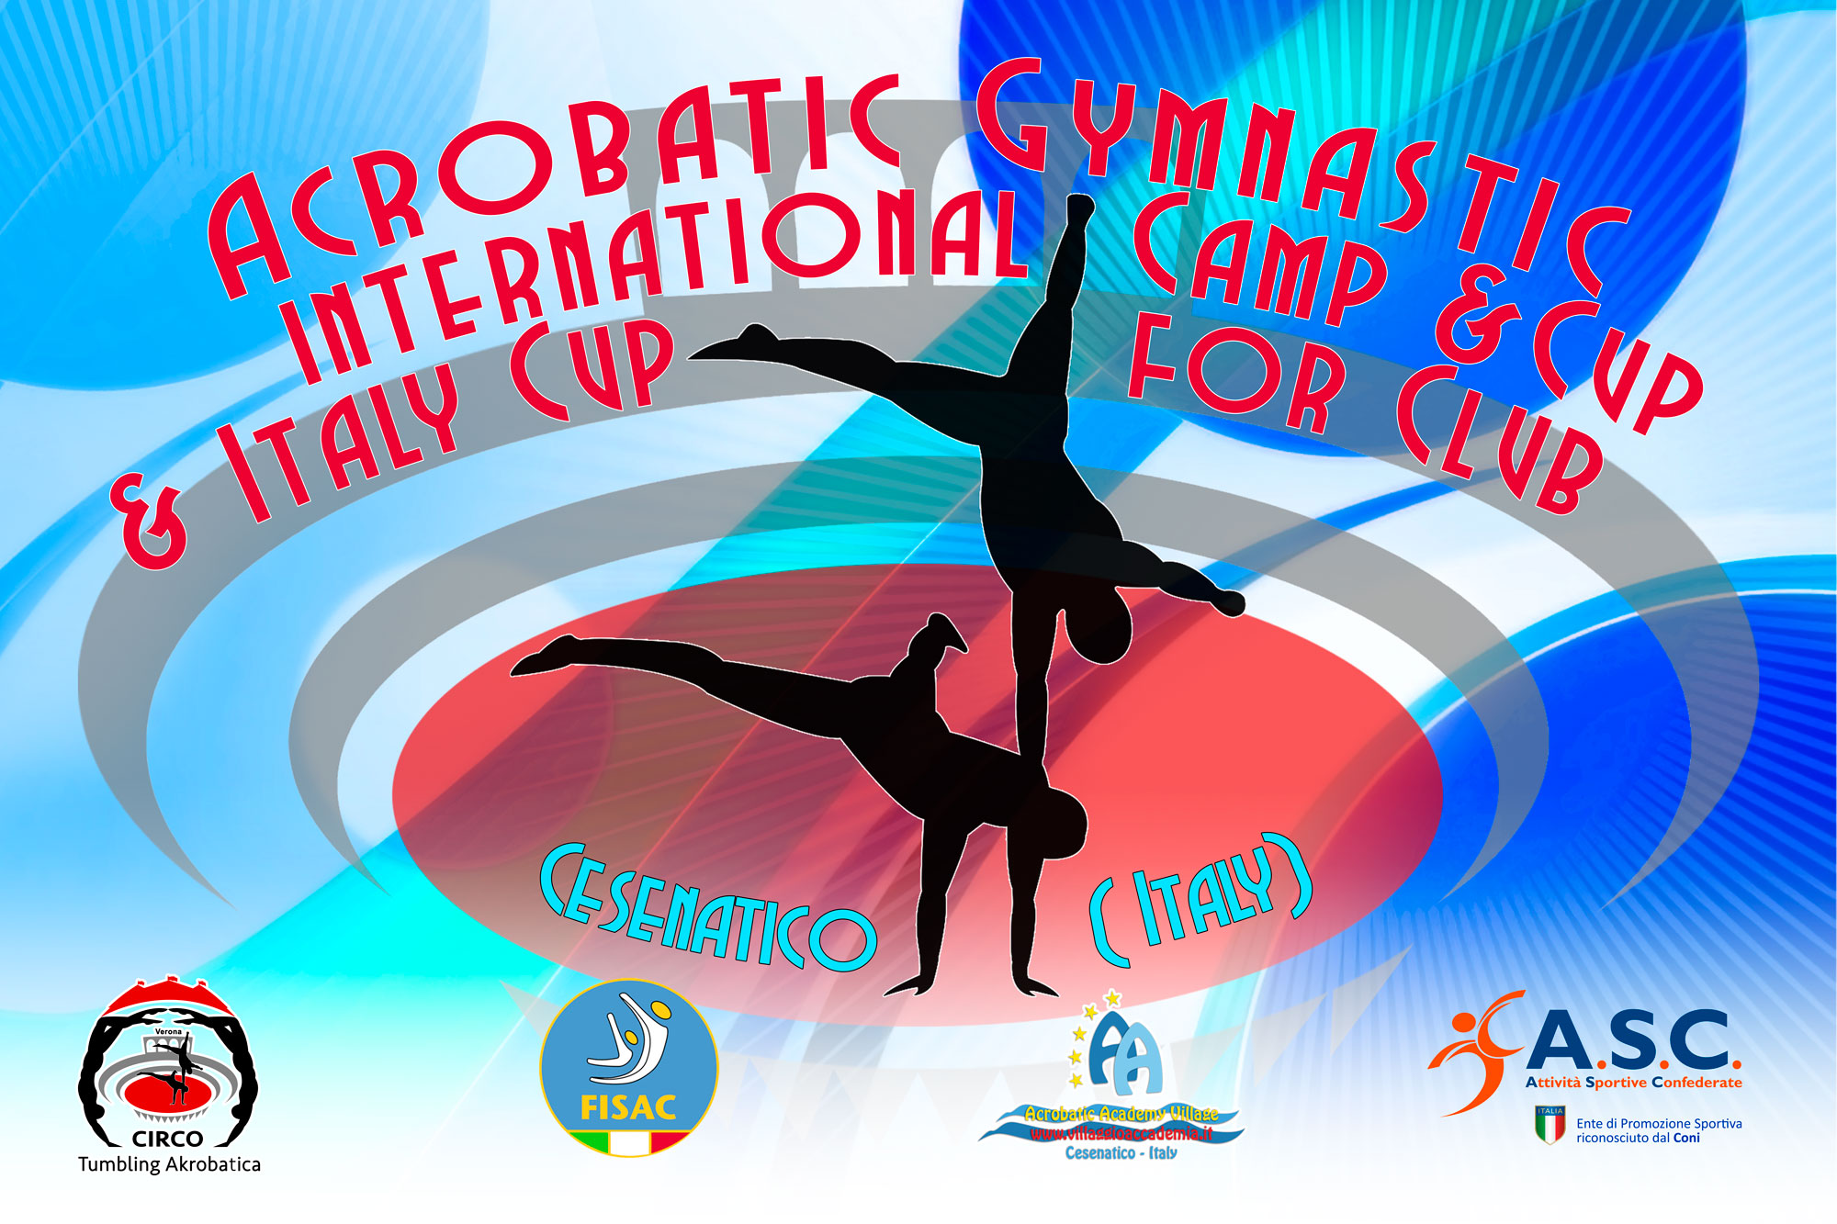
3° International Acrobatic Cup for Clubs 2017

Form to be send to
Organizing Committee
FISAC – FEDERAZIONE ITALIANA SPORT ACROBATICI E COREOGRAFICI
Viale. Cristoforo Colombo 35
47042 Cesenatico
direzione@villaggioaccademia.it
cesarebg@live.it

Deadline: SATURDAY 4 MARCH 2017

TRAVEL SCHEDULE FORM

Club/Country |  | Contact person:
 |  | Phone:
 |  | E-mail:
If the team delegation is scheduled on more than one transportation mean, please complete one (1) form for
each transportation mean. For earlier arrival or later departure please contact the OC.
Arrival information
№ of persons |  |  |  | № of luggage
Date: |  |  |  | Arrival time
By airplane | Airport: |  | Flight № |  | From
By train | Station: |  | Train № |  | From
By car

Departure information
№ of persons |  |  |  | № of luggage
Date: |  |  |  | Departure time
By airplane | Airport: |  | Flight № |  | To
By train | Station: |  | Train № |  | To
By car

Place and date:

