International Stage 2017 National Championship FISAC 2017
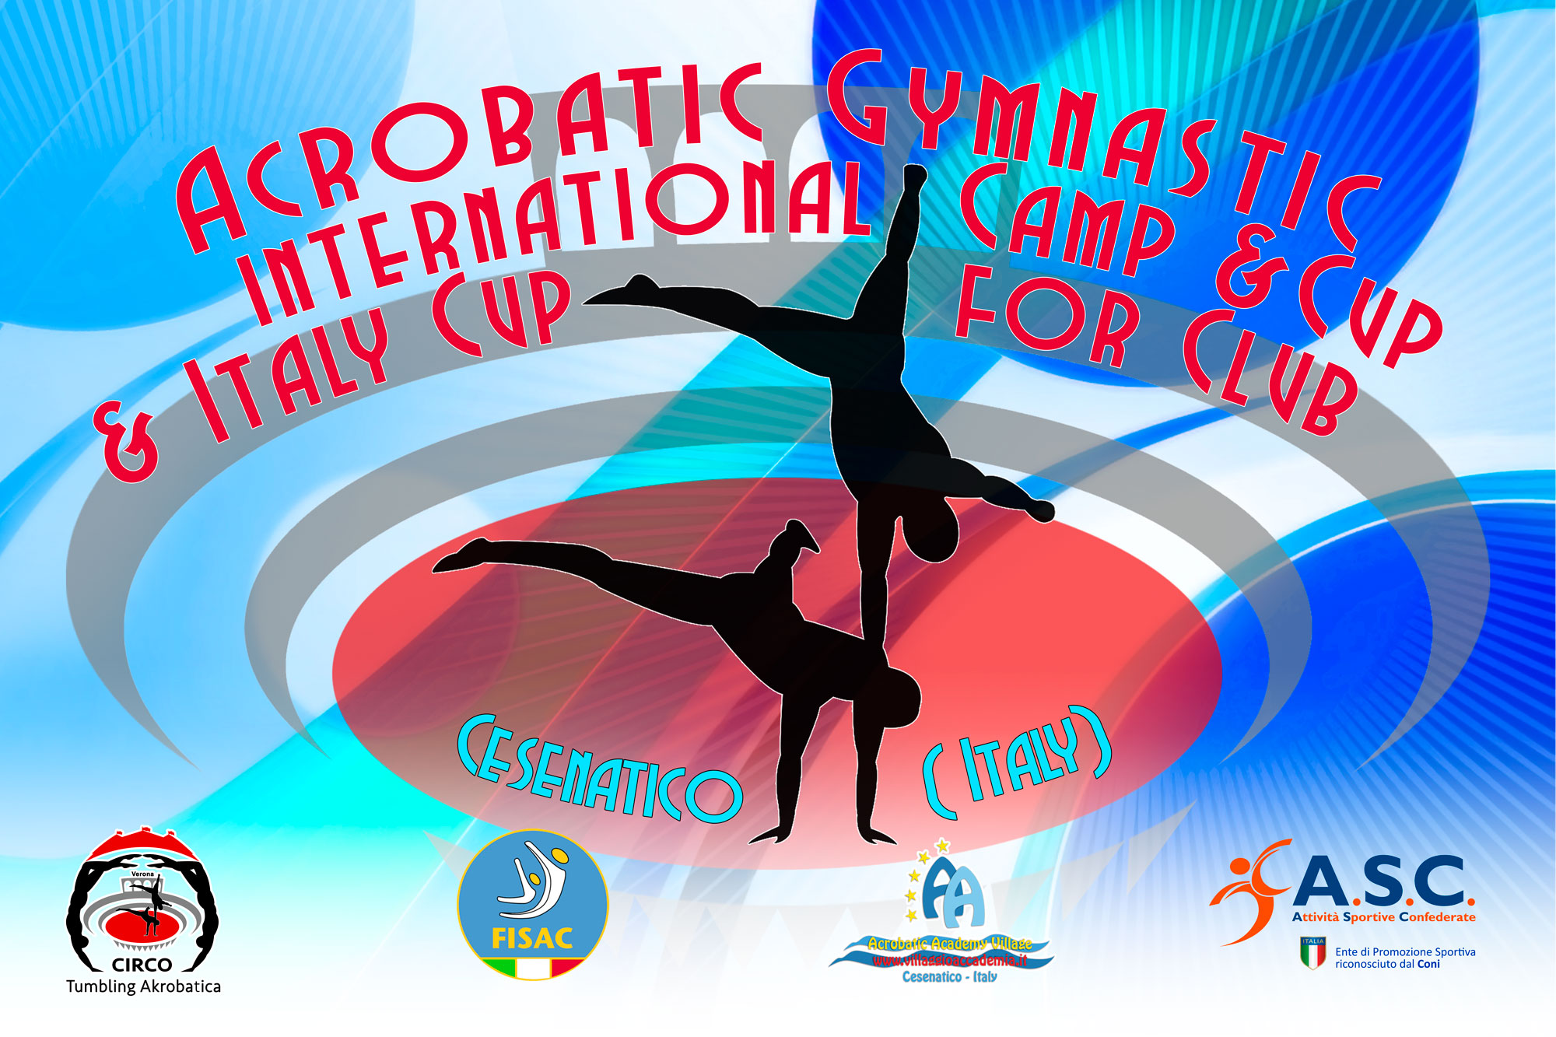
3° International Acrobatic Cup for Clubs2017

Form to be send to
Organizing Committee
FISAC – FEDERAZIONE ITALIANA SPORT ACROBATICI E COREOGRAFICI
Viale. Cristoforo Colombo 35
47042 Cesenatico
direzione@villaggioaccademia.it
cesarebg@live.it
Deadline: JANUARY 21 / 2017
NOMINATIVE REGISTRATION

Club/Country |  | Contact person:
 |  | Phone number:
 |  | E-mail:

Last Name, First Name | Category | MP | WP | Mix P | WG | MG | C | J
Total Gymnasts:
Total Coaches:
Total Judges:

Place and date:

