ACROSPORT Pre-registration to the International Easter Camp, International Cup for Clubs and Italian Fisac Championship
Given the considerable interest and the high number of possible participants in the International Camp, scheduled for Easter 2016 and the Cup competition, the Italian Federation of Acrobatic Sports asks you to submit, as soon as possible, no later than Saturday 06 February the attached form of pre-registration, to provide at all the participants the best possible organization. The mail reference is:

segreteria@fisacgym.it
cesarebg@live.it
Thanking you for your cooperation,
Best regards.

Cesenatico, 09 January 2015
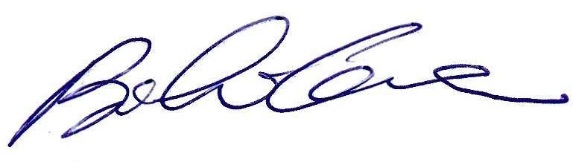
Il Presidente
(Bianchi Cesare)

Internazional Camp :

I (Name and Surname)_________________________________________________

Representing (Club)__________________________________________

confirms its participation in the International Acrobatic Easter Camp 2015, and reports the following numbers:

ATHLETS (about) __________________________

COACHES/JUDGES (about) _________________________

PARENTS/OTHERS (about) ______________

Internazional Cup e Italian Fisac Champ.

I (Name and Surname)_________________________________________________

Representing (Club)__________________________________________

confirms its participation in the Internazionale Acrosport Cup and reports the following numbers:

ATHLETS (about) __________________________

COACHES/JUDGES (about) _________________________

PARENTS/OTHERS (about) ______________

