Teamgym International Cup for Clubs 2019
Rules and Regulations
Introduction:

The rules have been updated by the UEG TG TC to provide a common guide line for TeamGym competitions outside of the European Championships.

- General
- The TG International Cup is a Club based series of competitions, set in several UEG member countries, that offers a way to give to all gymnasts, with a minimum age of 8 years old, the possibilities of representing their Club and competing internationally in TeamGym and Trio teams (Micro).
- There are several competitions around Europe, called ‘Steps’. Teams can take part in as many as they choose.
- The event is run by Paolo and Franca at the Academy Village in Cesenatico, Italy. They offer the prizes (see below) and collate the results from all the Steps.
- All Steps are organized by National Federations or Clubs. Entries must be submitted direct to the organizer of each Step at least two months prior to the event.
- Federations or Clubs wishing to host a Step, should apply to Paolo and Franca. Organizers must accept all Rules and Regulations proposed by these rules
- Step organizers will provide information about their step, including venue, dates, accommodation, sections offered, equipment available, tariff form submission and music submission, within their invitation.
- The International Cup offers competitions in TeamGym and is open to the following age categories.
  - Youth teams (combined – women, mixed and men compete in one division)
  - Junior teams (women, mixed and men)
  - Senior teams (women, mixed and men)
Competitions in Mini TeamGym and Micro Team sections may also be included.
- A gymnast can only take part in one team, which can only enter one category and one section, at each Step.
- The UEG CoP 2017 will be used, plus the “CHANGES” in these rules.
- Teams need to bring their own judges.
  - At least one judge per team (preferably National standard)
  - In every competition there should be AT LEAST one international judge (arranged by the hosts) as a head judge of the Competition.
- The winner of the Cup, in each category, is the team which has the highest combined score, from their two best scores, from the Steps they entered, (points plus the Ranking bonus), at the completion of all Steps.
- The Rules covering specific requirements for the categories, ages and sections are shown in the tables below.

- The Step organizers can open the competition to include Mini TeamGym and Micro Team (Also known as Trios) within the same Step.
- A Mini Team must be composed by 4 to 7 gymnasts - all the disciplines, Trampet, Tumbling and Floor
- A Micro Team must be composed by 3 to 5 gymnasts - only Trampet and Tumbling, no Floor
- Gymnasts who compete in Trio or Mini Team can not compete in TeamGym in the same competition step!

B. Ranking Bonus
- At each Step there will be a classification by category and section according to the final score for each team. Each participating team will be assigned a bonus relative to its position as follows:
- First place + 2.00 points
- Second place + 1.50
- Third place + 1.20
- Fourth place + 1.00
- And so on reducing by 0.2 for each place
- In all the sections and categories, only teams that have participated in at least 2 Steps of the International Cup, will be taken into account. Their score is the sum of the two best Steps plus the respective Bonuses.
- The prizes are at the discretion of the individual organizers of each step. In addition, the following awards are offered by the Academy Village.
C. Prizes presented by the Academy Village
For placed participating teams (Max 12 gymnasts and 2 coaches)
- TeamGym - Youth (Combined), Junior (M, W and Mix) and Senior (M, W and Mix)
- 1st place: A completely free, one week stay at the A.V. (Academy Village- Cesenatico- Italy)
- 2nd place: A 50% discount for one week stay at the A.V.
- 3rd place: A 30% discount for one week stay at the A.V.

- Mini TeamGym - Youth (Combined), Junior (M, W and Mix) and Senior (M, W and Mix)
- 1st place: A completely free, one week stay at the A.V.
- 2nd place: A 50% discount for one week stay at the A.V.
- 3rd place: A 30% discount for one week stay at the A.V.

- Trio Teams - Youth (Combined), Junior (M, W and Mix) and Senior (M, W and Mix)
- 1st place: A completely free, one week stay at the A.V.
- 2nd place: A 50% discount for one week stay at the A.V.
- 3rd place: A 30% discount for one week stay at the A.V.
For all TeamGym, Mini TeamGym and Micro Team disciplines, the above conditions will be valid only if in the final rankings there are 3 or more teams.
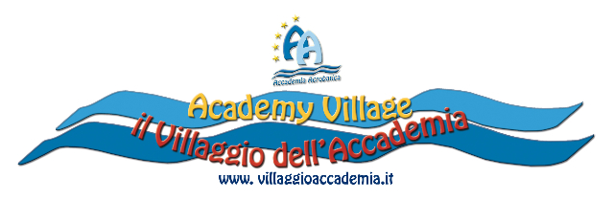
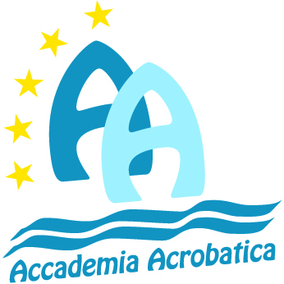
Sponsored by:

