International Training
National Championship FISAC 2019
5° International Acrobatic Cup for Clubs 2019

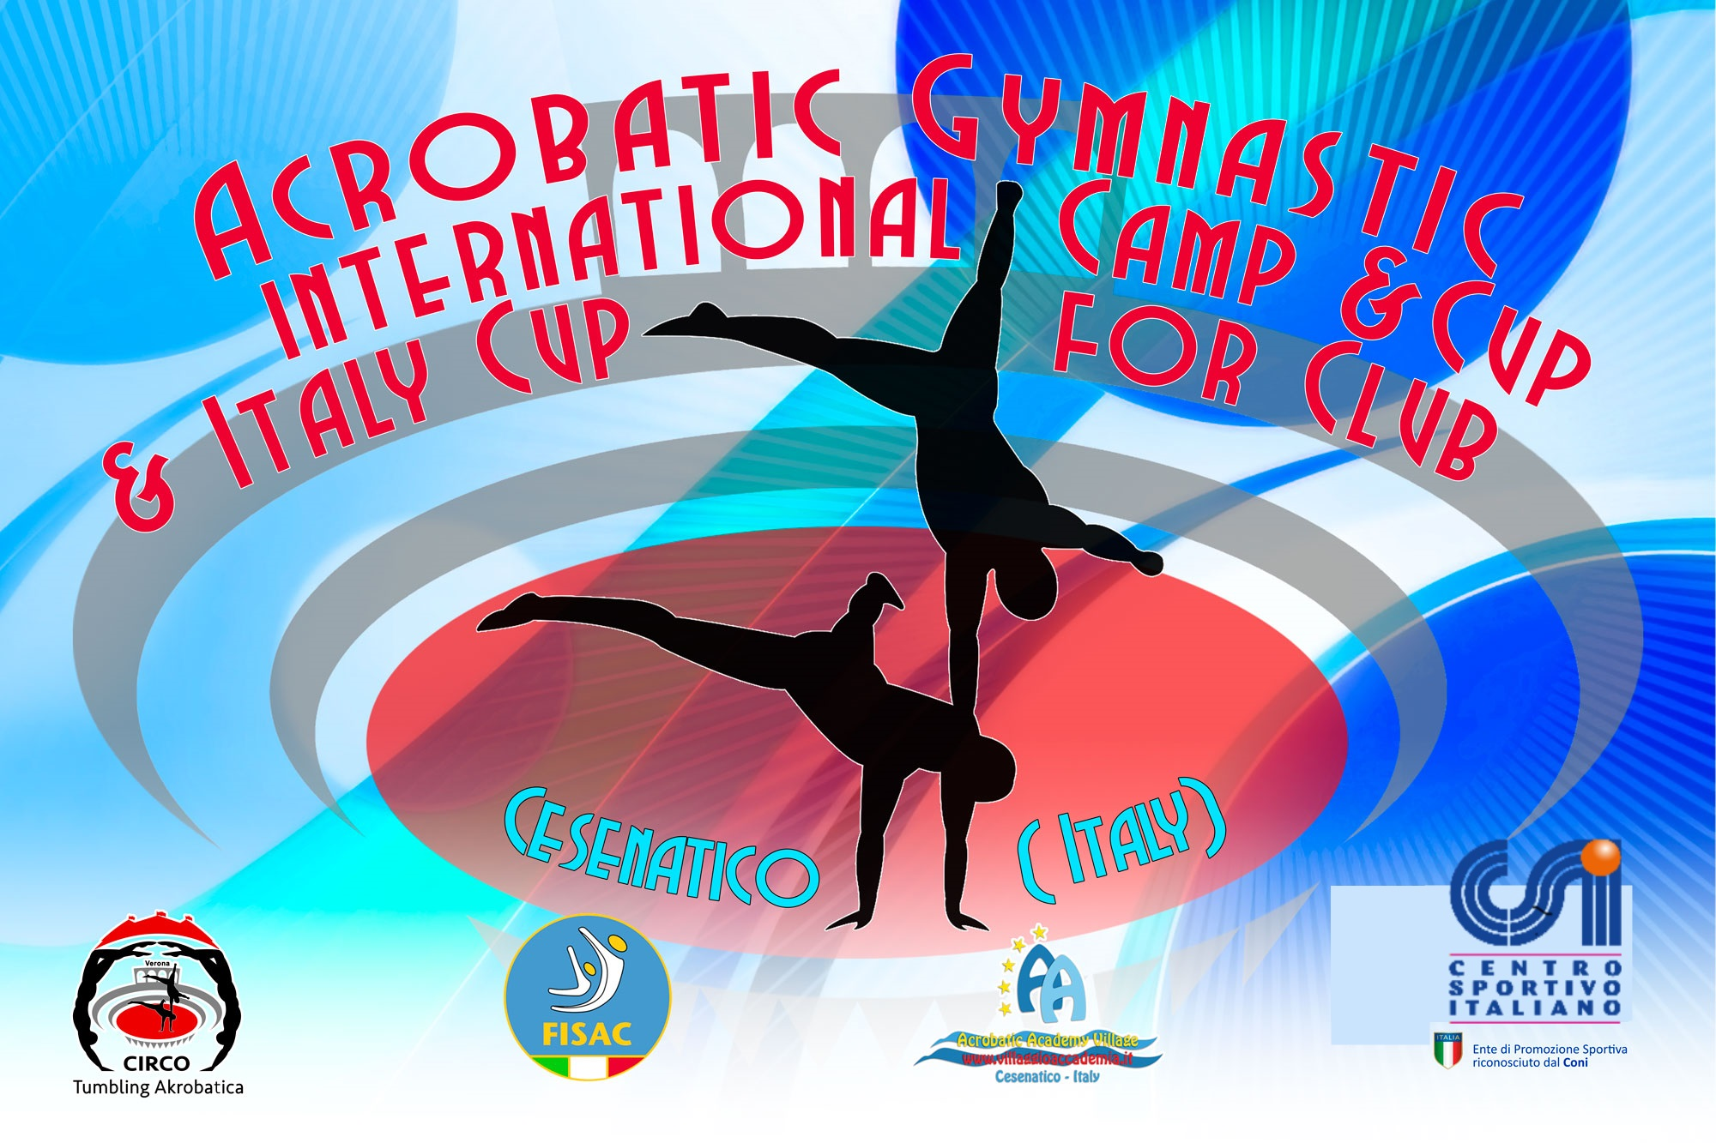

CESENATICO ITALIA
April 2019
- International Training 18-19/04
- 5 °International Championship FISAC Cup - for clubs 20-21/04

FISAC has as its goal the development and diffusion of Acrobatics in Italy and Europe and after the success of the International Team gym Cup to which 15 countries now participate with over 70 Teams, has also set the International Acrobatic Cup.
At the Last Edition in 2018 over 300 Athletes from different clubs and nations have participated like Bulgaria, Germany, Moldova, Hungary, Portugal, England, Puerto Rico, Switzerland, and Italy.

With the collaboration of the Acrobatic Academy of Cesenatico, Federal National Technical Head Quartier, FISAC will offer at the participants a substantial economic help to this international competition and at the NATIONAL CHAMPIONSHIPS 2019!

FISAC NATIONAL ACROBATIC CHAMPIONSHIPS will be open to all Clubs (Sport Clubs) which will request them, from any other Federations and/or Sport Promotion Association. FISAC membership is COMPLETELY FREE for the first year and in this way, it will give CONSIDERABLE FACILITY!

GENERAL INFORMATION

COMPETITION ORGANIZERS | FISAC – FEDERAZIONE ITALIANA SPORT ACROBATICI E COREOGRAFICI  Viale. Cristoforo Colombo 35  47042 Cesenatico  direzione@villaggioaccademia.it ( Accomodation Info )  cesare.yankov@fisacgym.it ( Competition Info )
LOCATION | CESENATICO - ITALIA
DATES | From 18 APRIL to 21 APRIL 2018
VENUE | 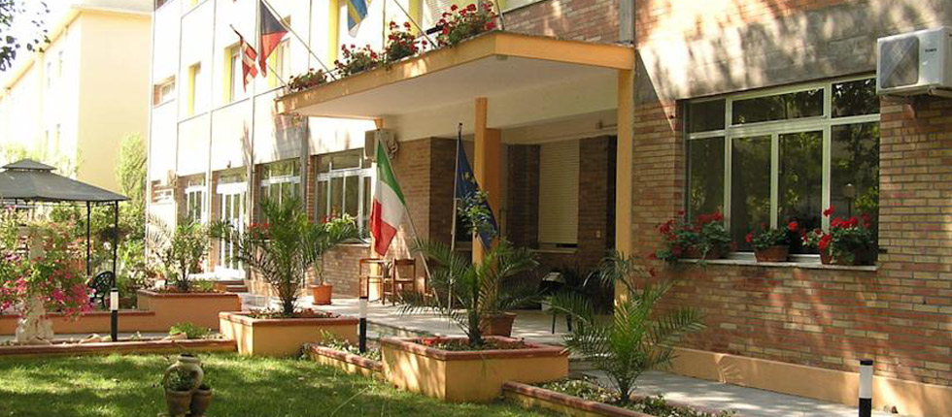  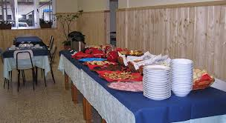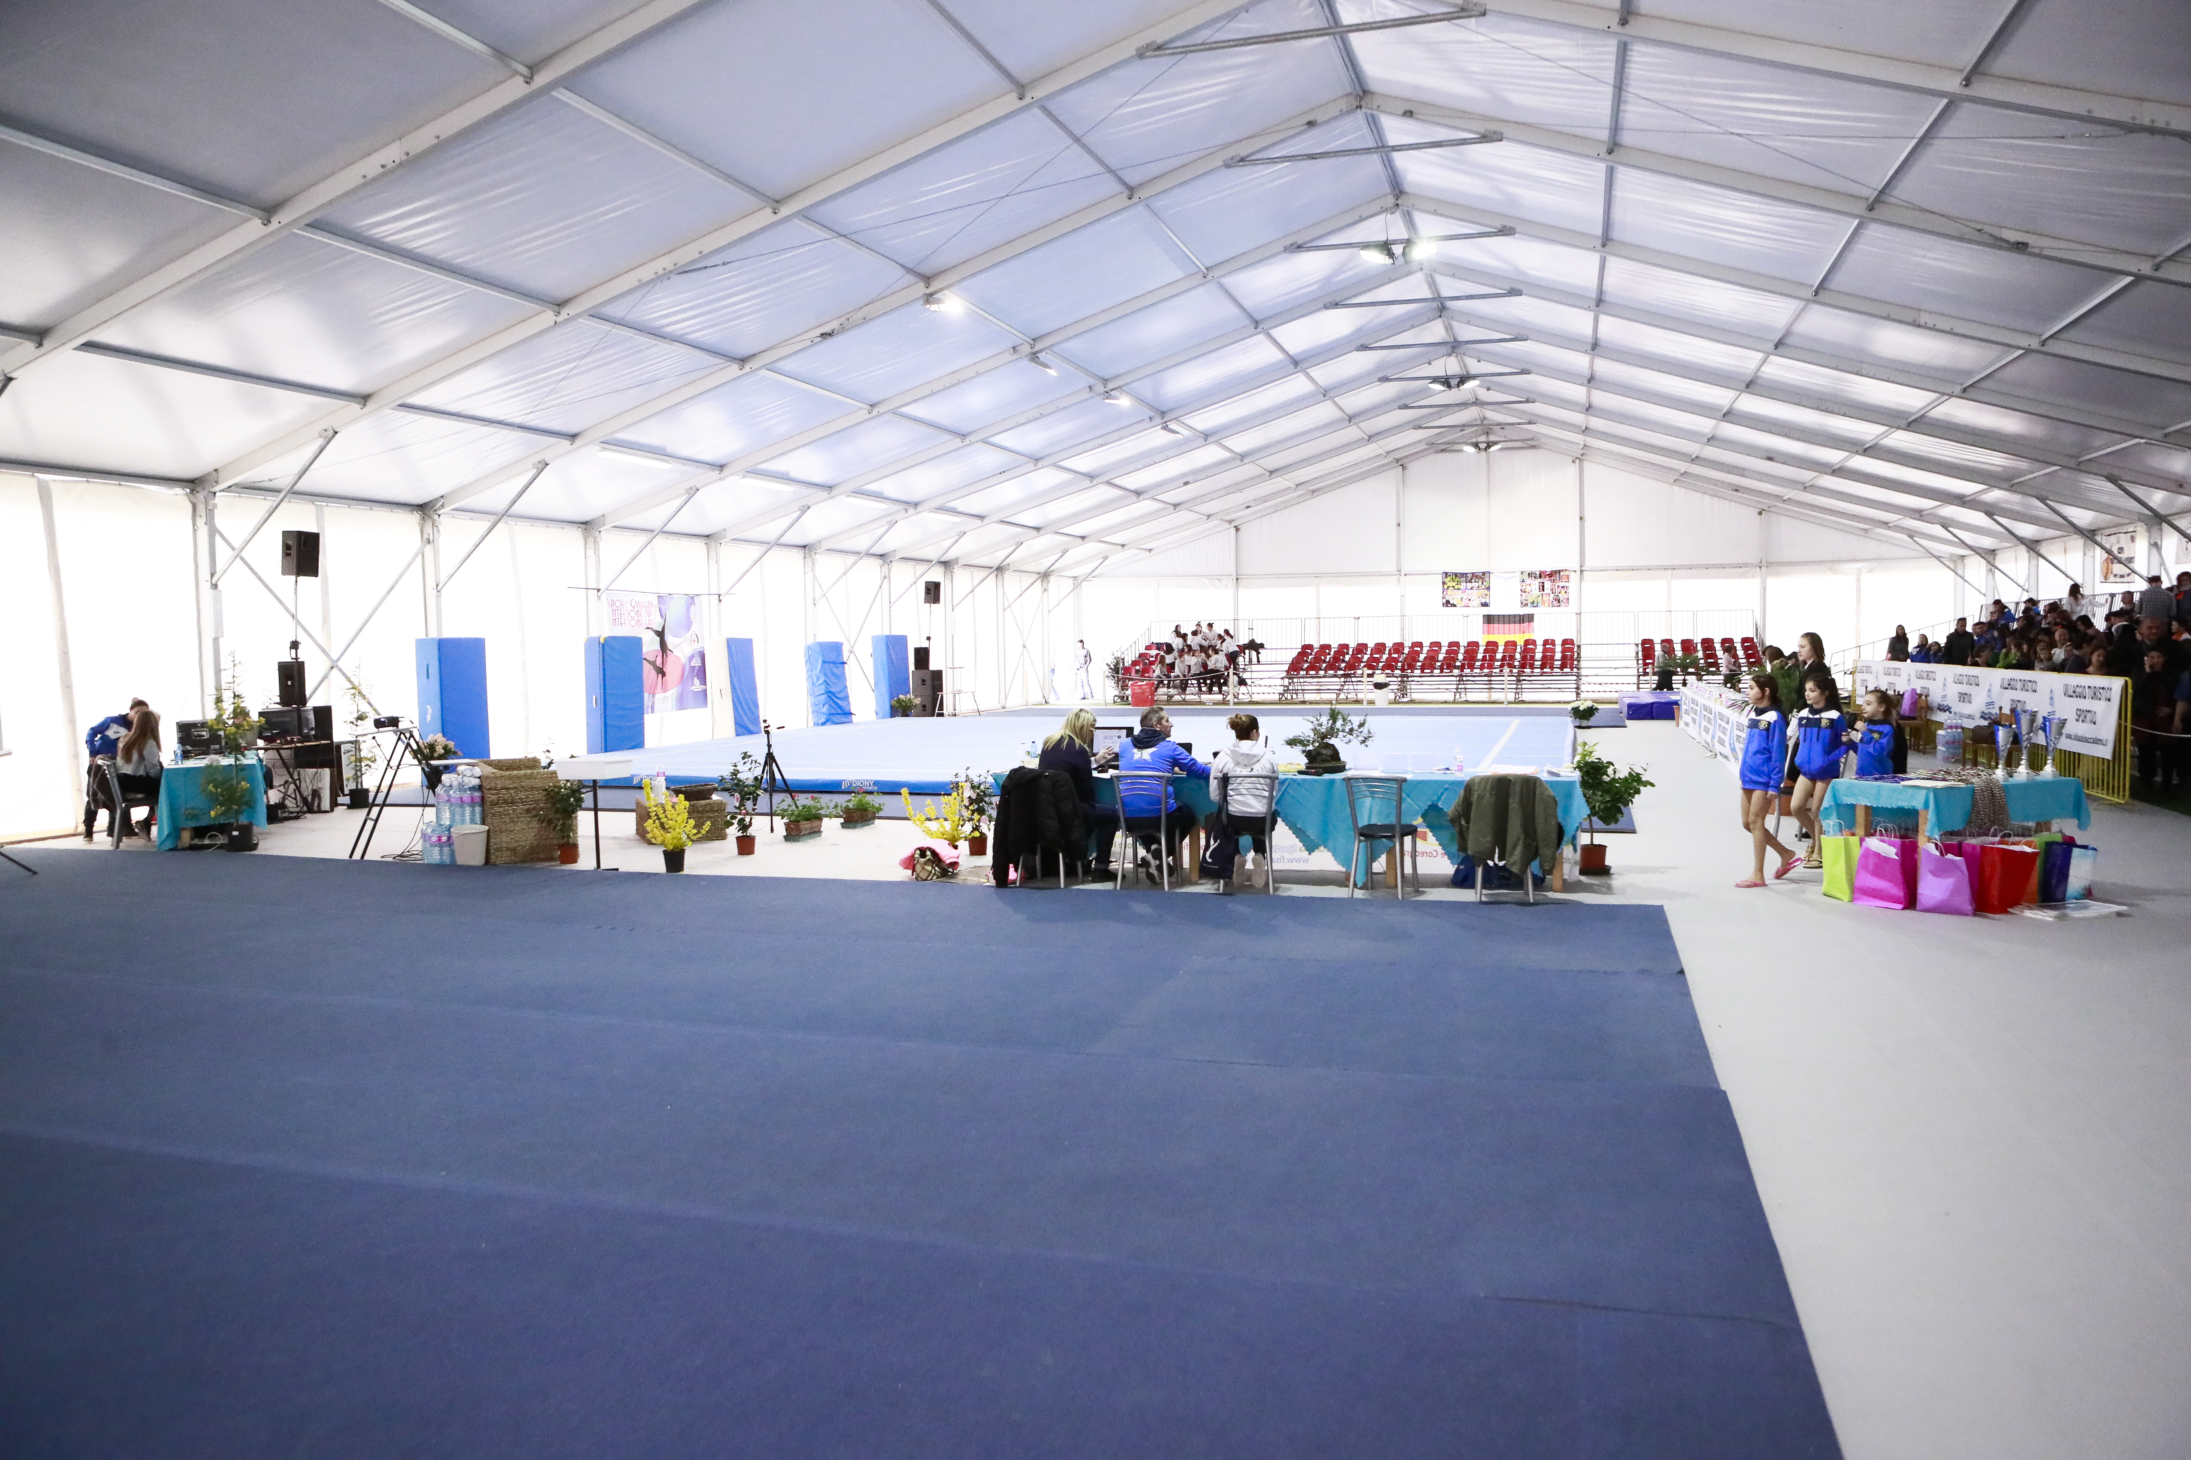  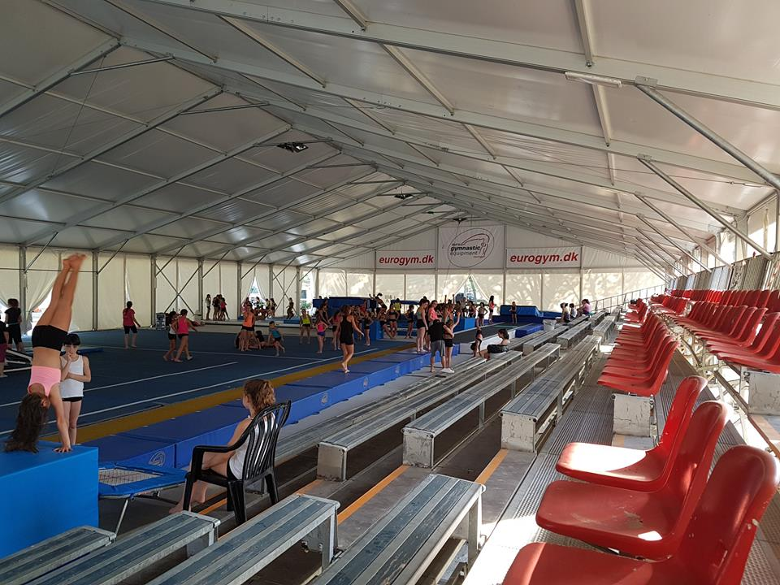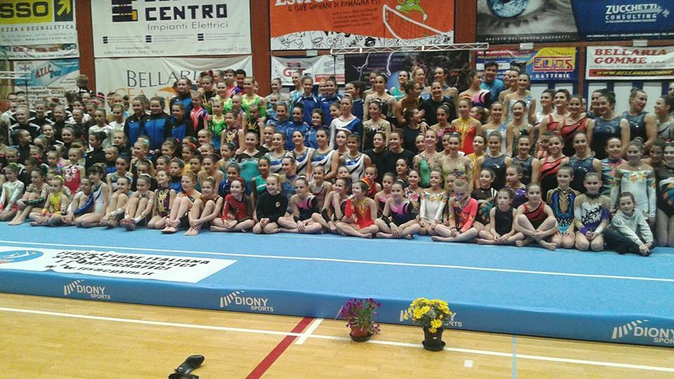
REGISTRATION DEADLINES | The price for the stay for careers always at the quarters is 35€ with the full pension treatment (drinks included).  The price for the stay (full pension) at the Acrobatic academy quarters for athletes and technicians is 35€ per day included also with transportation to and from the Station of Cesenatico  The accommodation payment and transfer has to be made within 18 March 2019 by bank transfer to the following account:  CREDITO COPERATIVO ROMAGNOLO  ACCADEMIA ACROBATICA SRL  IBAN: IT79P0707024000010000847348  C/C Numero: 10-000847348  BIC: ICRAITRRTQO  Reason for Payment: (Name of the Club and number of full delegation )  IMPORTANT / ACCOMODATION / TRANSFER /  For more organizational and logistical information you can call the following numbers:  FISAC Secretary and Presidency  +39 380 2982176 - 0547-84935 and ask for Franca  franca.casadei@fisacgym.it  For more Technical information:  National Technical Direction - Lachezar Cesare Yankov  +39 348 3814080  cesarebg@live.it / cesare.yankov@fisacgym.it
ENTRY FEE Training end Competition  Categories | The price of the Training previously to the competition is 10 € per athlete (Full training, use structures and tools of the Federation FISAC ), for those who will participate at the National Championship and the International Cup for Clubs For Those who will NOT participate in the Competition, the price will be 30 € ( full training camp, use structures end tools and coaches of the Federation FISAC )  Entry to the competition is 15 € for Athlete. ( C1,C2,Podest )  Entry to the competition is 20 € for Athlete. ( B2,Age Group, Senior)  Training and competition, you pay in Acrobatic Academy.
VISA | If you need an official invitation to obtain a visa to travel to Italy , please contact us as soon as possible, no later than 17 ^{th} of December 2018 (please, fill the necessary documents).
INSURANCE | The organizer is not responsible for any liability in the case of accidents.  Therefore, all participants are advised to look for adequate insurance coverage.
INTERNATIONAL TRANSPORTATION | Free transport from and to the Station of Cesenatico.  Bologna Airport for groups of at least 8 people is 20€ each way. 40€ in total from and to Bologna Airport.  For groups less than 8 people price still to decide. Arrivals to other Airports still to calculate.
ACCOMODATION  end Special Offers for Clubs | Every Club with more than 10 registered Athletes at the Championship and at the Training (both) will have a complimentary stay for 1 Technician and 1 judge for the entire period.  Every Club with less than 10 registered Athletes will have a complimentary stay for 1 Judge for the entire period.
FINAL BANQUET | Saturday, the 20th March 2019
PROVISIONAL SCHEDULE | Thursday, 18th APRIL  Arrival of Delegations and accommodation. Training in Academy. Technical meeting for the judges and coaches.  Friday, 19 APRIL  Training in Academy.  Saturday, 20th APRIL  Opening ceremony  Competition  Banquet – Farewell party  Sunday 21th April  Competition  Gala performances  Awards Ceremony  Monday 22th end Tuesday 23 April  Excursion to Cesenatico / Departure of the delegations
GALA | We welcome any delegation to participate in the Gala performance which will take place before the awarding ceremony on APRIL 19 th. Please, inform us about your gala performance in your registration.
AWARDS | ACRO  You can take part with more pairs and groups per category, but only one of them per club per category Age 11-16/12-18/13-19/Seniors will take part on the final (those who has the best score).The organizers can take part with more gymnasts from club per category, but only 2 of them can be rank.  Individual all around (for each category)  First 3 positions will be award with medal: Gold-Silver-Bronze.  Certificate : Every Participant  CUP: Team Competition  TEAM COMPETITION – Mainz (GER) and Cesenatico (IT)  International Acrobatic Cup 2018-2019 Ranking and Prices  The Following Rules are only for the TWO competitions  Mainz (GER) and Cesenatico (IT)  Ranking  Final Results: In all the compositions and categories are admitted to the final classification only combinations that have participated in at least 2 steps of the International Cup and the classification will be drawn up taking into account the sum of the two best steps more the “Bonus”.  Prizes: The prizes are at the discretion of the individual stages of O.C. of each step. The final classification of awards are offered by the "Village Academy" with any other prizes offered by other sponsors.  Prizes: The prizes are at the discretion of the individual stages of O.C. of each step. The final classification of awards are offered by the "Village Academy" with any other prizes offered by other sponsors.  Prizes  • 1 ° place, one-week stay at the A.V. (Academy Village- Cesenatico- Italy) + 1 coaches, completely free.  • At the 2nd one-week stay at the A.V. + 1 coaches, with 50% discount.  • At the 3rd, one-week stay at the A.V. + 1 coaches, with 30% discount.  *Prizes will include 10 athletes + 1 coach  The above conditions will be valid only if in the final rankings will be 3 or more combinations in each categories.  Sponsored by:
BANK ACCOUNT INFORMATION  Technical Information for Championship al Category | Payments must be pay as follows:  The accommodation payment and transfer has to be made within Saturday 30 March 2019 by bank transfer to the following account:  CREDITO COPERATIVO ROMAGNOLO  ACCADEMIA ACROBATICA SRL  IBAN: IT79P0707024000010000847348  C/C Numero: 10-000847348  BIC: ICRAITRRTQO  Reason for Payment: (Name of the Club and number of person.)  Definitive :  Tariff Sheet – Saturday 30 March  acrocupfisac@gmail.com  Musik – Saturday 30 March  acromusicfisac@gmail.com
DEADLINES SUMMARY | DEFINITIVE REGISTRATION Saturday 09 March 2019  VISA REQUEST FORM Saturday 15 December 2018 - Definitive  NOMINATIVE REGISTRATION Saturday 02 February 2019 - Provisional ( Declaration of interest end name of Clubs ) Saturday 09 March 2019 – Definitive ( names of gymnast, category , judges )  TRAVEL SCHEDULE FORM Saturday 02 March 2019 - Provisional ( Declaration of interest end name of Clubs ) Saturday 30 March 2019 – Definitive ( names of gymnast, category , judges )  ACCOMODATION FORM Saturday 02 February 2019 - Provisional ( Declaration of interest end name of Clubs ) Saturday 02 March 2019 – Definitive ( names of gymnast, category , judges )  PAYMENT OF THE ENTRY FEE Training and competition you pay in Acrobatic Academy.  PAYMENT OF ACCOMODATION Saturday 30 March 2019 – Definitive

TECHICAL INFORMAZION
FOR REQUIRIMENTS

TEDESCO – g.kiryakov@gmax.net / mgraw@gmax.net

ITALIANO, RUSSO, BILGARO, POLACO – cesarebg@live.it cesare.yankov@fisacgym.it

TECHNICAL REQUIREMENTS
ACROBATIC GYMNASTICS
For Open Group
Group C1 / C2 – Combined
(Group C3 – Combined – ONLI Italian Championship)
Group B2 – Static, Dynamic
Podest – Individual W/M (C1, C2, B)
Age Group / 08-16 / 11-18 /12-19 / seniors

Group C  C1 / 6 – 14 anni  C2 / fino 19 anni | Requisiti  Minimi: | Requisiti Speciali: | Composizione del esercizio
Combinato  2.30  E’ AMMESSA LA MUSICA CON LE PAROLE | 1 elemento Statico – categoria 1  1 elemento Statico – categoria 2  1 elemento Statico – categoria 3  3 elementi dinamici.  3 elementi  Individuali  1 elemento Categoria 1  1 elemento  Categoria 2 | 1 elemento di presa  Maximum 2 arrivi a terra dal Partner.  Totale 5 arrivi a terra  Maximum 3 posizioni di partenze e prese uguali.  Statici:  Il top un elemento uguale maximum 2 volte – Posizione Statica e 2 volte in transizione della base. | Referente codice DSAB.  Maximum 8 elementi (minimo 6 elementi) di gruppo e 3 elementi individuali.  Il terzo elemento individuale – libero - dalle categorie 1 o 2.  Differenza tra elementi statici e dinamici 50%.  Difficoltà 80 = 0,8 Massimo  + 10 Tolleranza.  Coppie: La base NON può ripetere la stessa posizione  Gruppo: se la Top e la Mezzana, sono nella stessa posizione si conta una sola volta (es.: due squadre valgono come una)

CRUPPO  C 3 - IT competizione | Requisiti  Minimi | Requisiti  Speciali | Composizione del Esercizio
Combinato  2.30  (Programma per atlete principianti -una ginnasta può partecipare al max. a due esercizi nella cat. C3)  E’ AMMESSA LA MUSICA CON LE PAROLE | 1 elementi Statici – categoria 1  1 elemento Statico – categoria 2  2 elementi dinamici  3 elementi individuali  1 elemento individuale – categoria. 1  1 elemento individuale – categoria. 2 | Libero  MAX. PUNTEGGIO ELEMENTO STATICO-DINAMICO-INDIVIDUALE V. 4 | Referente codice DSAB.  Maximum 6 elementi (minimo 4 elementi) di gruppo e 3 elementi individuali per la difficoltà.  Il terzo elemento individuale – libera scelta dalle categorie 1 o 2.  Differenza tra elementi statici e dinamici 50%.  Difficoltà max. 30 = 0,3 Massimo

Group B2  Coppie / Pairs | Requisiti  Minimi: | Requisiti  Speciali: | Pairs  Balance
Statico 2.30  Max. 80V + 10 T  AGE 12 - 18  Senza limiti di età tra le partner.  Età minima 8 anni (per la top) | * COPPIE  *Minimo: 5 elementi, con minimo 3 posizioni da 3”  *Tutti gli elementi devono avere difficoltà minima V1.  * Una transizione obbligatoria della Top esempio:  (Squadra – coccodrillo)  (In piedi – discesa in spaccata della base)  * NON è obbligatoria la verticale (per la top) e il Salto per elementi individuali per tutti. | *Maximum 8 elementi di coppia.  Una posizione statica per la top, può essere ripetuta max. 4 volte. (Ad esempio: la verticale 2 volte in posizione statica e 2 volte con transizione della base).  * Maximum 3 elementi individuali per la difficolta V categoria 1.  Flessibilità, Balance, Agilità  *Valgono Tutti i Requisiti Speciali per esercizi STATICI in Vigore FIG:  Age Group 12-18 | O at least 5 partner elements with a minimum of 3 static positions with 3” stop by the top. Maxsimal 8 Partner elements.  O at least 1 motion by the top or the base  O at least 3 individually elements of category 1  Special requirements:  • an individually somersault or back flip is not required  • a handstand of the top isn’t required  • There are all the other restrictions of the World
* la categoria B2 -  Gruppo / Group  Possono eseguire anche solo un esercizio a scelta tra statico o dinamico.  Classifica separata.  (NON C’E’ LA SOMMA DEI PUNTEGGI PER ESERCIZIO STATICO E DINAMICO)  E’ AMMESSA LA MUSICA CON LE PAROLE (solo in un esercizio – statico o dinamico) | GRUPPO/GROUPS  *Minimo 2 piramidi separate da diverse categorie, con 3 posizione statiche tenute 3” ognuna.  * Obbligatoria una Motion,Transizione (esempio: squadra, coccodrillo. )  * NON e obbligatoria la verticale (per la top sulla piramide) | *Maximum 4 piramidi separate in un esercizio di diverse categorie.  *La difficoltà per la transizione si prende quando da una posa statica x 3” si va ad un’altra posa statica x 3”  *La Top può ricevere la difficoltà per la stessa posizione in una combinazione:  * 2 volte per la statica  * 2 volte per la transizione  *Maximum 3 elementi individuali per la difficolta V. Categoria 1.  Valgono Tutti i Requisiti Speciali per gli esercizi STATICI in Vigore FIG  Age Group 12-18 | GROUPS  O at least 2 single pyramids of different categories with a minimum of 3 static positions with  3” stop by the top  O A maximum of 4 pyramids, all different categories  O at least 1 motion by the top  O at least 3 individually elements by category 1  Special requirements:  • an individually somersault or back flip is not required  • a handstand of the top isn’t required  • There are all the other restrictions of the World Age Group Competition Rules 12-18.
Dinamico  2.00 | Requisiti  Minimi: | Requisiti  Speciali: | DYNAMIC  2,00”  basic requirements:
Coppie /Gruppi  Max. 70V + 10T  AGE 12 – 18  Senza limiti di età tra le partner.  Età minima 8 anni (per la top) | *Minimo 5 elementi Dinamici con fase di Volo.  * Due 2 dei quali con ripresa del partner.  *Max. 3 arrivi a terra (dal partner a terra)  *Tutti gli elementi devono avere difficoltà minima V1.  * NON e obbligatorio Salto per gli elementi di gruppo e coppie, come anche per gli elementi individuali. | *Maximum 8 elementi di gruppo per difficolta V.  *Minimum 2 e max. 3 elementi individuali per la difficoltà V Categoria 2.  *Valgono Tutti i Requisiti Speciali per gli esercizi STATICI in Vigore FIG  Age Group 12-18 | • at least 5, maximum of 8 partner elements, from that  O at least 2 elements to the partner and  O maximum 3 bounces (from partner to the floor)  o at least 2 individually elements of the category 2  Special requirements:  • an individually somersault or back flip is not required  • There are all the other restrictions of the World Age Group Competition Rules 12-18.

Podest  2,30 | Requisiti  Minimi: | Requisiti  Speciali: | Composizione del esercizio
Disciplina  Individuale.  W/ M  Esercizio Combinato.  Elementi di verticali e posizioni di equilibrio in varie forme, eseguiti su un tavolino di verticalismo.  Esercizio coreografato. | Allieve: “C “  C1 - (6 – 14)  C2 - (15 - 19)  *Difficolta massima 60V.  - (va divisa x 100 / = 0,60)  Junior: “B” Classe  (NON limite d età – stesse regole della cat. C)  * Difficolta massima 80 V – (va divisa x 100 /= 0,80)  Master Class:  Nessun limite d’età ma segue il programma 12-19 FIG Combinato  * Difficolta massima 80 V – (va divisa x 100 /= 0,80  * Tolleranza + 20 V  * Elementi delle Tabelle da 1 a 5 di pag. 3 e pag. 4 con 360° Raddoppiano il punteggio.  Obbligatorio il SALTO | Allieve e Junior  3 Elementi. Statici di diverse categorie.  3 Elementi. Dinamici con 360° giro di diverse categorie.  Maximum 8 elementi.  Individuali:  1 categoria / uno  1 categoria / due  Max. 3 elementi individuali  Master Class  3 Elementi. Statici di Diverse categorie  3 Elementi Dinamici con 360° di giro di diverse categorie  Individuali: (max. 3)  1 categoria / uno  2 categoria / uno  (Dal Cod. FIG)  Max. 8 Elementi | Allieve e Junior  Almeno 2 discese libere dal Tavolino.  Maximum 1 discesa con valore per la difficolta (ma non e obbligatoria)  * Elementi statici possono essere ripetuti come Dinamici con 360°  * Verticale, Flick e Salto NON sono obbligatori.  Master Class  Maximum 4 el. eseguiti in serie, statici e dinamici possono essere collegati.  * Uno dei elementi deve essere la verticale dalle categorie A/B/B1/C/D/E  Pag. 1 programma podest  * Elementi statici possono essere ripetuti come Dinamici con 360°  * Salto deve essere eseguito.  * Minimum 2 discese dal Tavolino

TECHNICAL REQUIREMENTS
ACROBATIC GYMNASTICS
Age Group 08-16/11-18/12-19/ Senior
FIG / 2017 – 2020 /
(Aggiornamento Newsletter - FIG)

AGE GROUPS | QUALIFICATIONS | FINALS | COMPOSITION OF EXERCISES
08-16 | Each pair and group presents one Balance and one Dynamic exercise.  The exercise is composed of compulsory and optional elements. The performance order is set by draw.  Ranking after the qualifications is determined by the sum of scores from the two Exercises: Balance and Dynamic.  The top 8 proceed to a Final with not more than one from each club in each category.  Competitors cannot participate in the Final without competing in both Balance and Dynamic qualifying events. | Marking starts from Zero.  In the final, pairs and groups will present one exercise:  Women’s Pairs: Dynamic  Mixed Pairs: Balance  Men’s Pairs: Dynamic  Women’s Groups: Balance  Men’s Groups: Dynamic  The reverse standing of the sum sets the performance order in the Final from both Balance and Dynamic exercises. | According to FIG Rules for  Age Group 11-16  Difference of Age max. 6 years
11-18 | Each pair and group presents one Balance and one Dynamic exercise. The performance order is set by draw.  Ranking after the qualifications is determined by the sum of scores from the two exercises: Balance and Dynamic.  The top 8 proceed to a Final with not more than one from each club in each category.  Competitors cannot participate in the Final without competing in both Balance and Dynamic qualifying events. | Each Pair and group performs one Combined exercise in the finals.  Marking starts from zero.  The performance order in the Final is set by the reverse standing of the sum from both Balance and Dynamic exercises. | According to FIG Rules for  Age Group 12-18  Difference of Age max. 6 years
12-19 | Each pair and group presents one Balance and one Dynamic exercise.  The performance order is set by draw.  Ranking after the qualifications is determined by the sum of scores from the two Exercises: Balance and Dynamic.  The top 8 proceed to the Final with not more than one from each club in each category.  Competitors cannot participate in the Final without competing in both Balance and Dynamic qualifying events. | Each Pair and group performs one Combined exercise in the finals.  Marking starts from zero.  The performance order in the Final is set by the reverse standing of the sum from both Balance and Dynamic exercises. | According to FIG Rules for  Age Group 13-19  Difference of Age max. 6 years
Senior  + 13 | Each pair and group presents one Balance and one Dynamic exercise.  The performance order is set by draw.  Ranking after the qualifications is determined by the sum of scores from the two Exercises: Balance and Dynamic.  The top 8 proceed to the Final with not more than one from each club in each category.  Competitors cannot participate in the Final without competing in both Balance and Dynamic qualifying events. | Each Pair and group performs one Combined exercise in the finals.  Marking starts from zero.  The reverse standing of the sum sets the performance order in the Final from both Balance and Dynamic exercises. | According to FIG  Rules for  Senior

