International Stage 2018
National Championship FISAC 2018
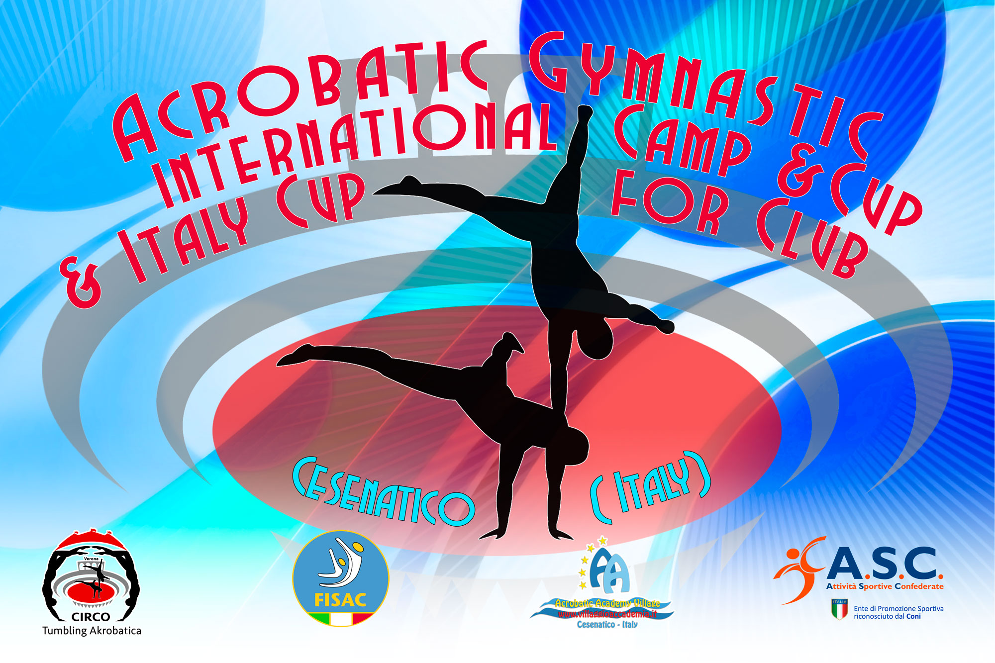
4° International Acrobatic Cup for Clubs 2018
Form to be send to
Organizing Committee
FISAC – FEDERAZIONE ITALIANA SPORT ACROBATICI E COREOGRAFICI
Viale. Cristoforo Colombo 35
47042 Cesenatico
direzione@villaggioaccademia.it
cesarebg@live.it

Deadline: Saturday 18 December 2017

VISA REQUEST FORM

Club/Country |  | Contact person:
 |  | Phone number:
 |  | E-mail:

Last Name, First Name | Function | Gender  M/F | Date of Birth  (dd.mm.yyyy) | Passport N° | Passport Expiry Date | Arrival Date | Departure Date
1.
2.
3.
4.
5.
6.
7.
8.
9.
10.
11.
12.
13.
14.
15.
16.
17.
18.
19.
20.

Place and date:

