TeamGym International Cup for Clubs 2017

E. Dates and Venues:

05-06 May Czech Republic – Prague
mail : cgf@gymfed.cz

28 May Austria - Dornbirn
email : marieluise.kogler@A1.net

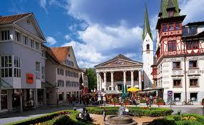

03-04 June Scotland – Dundee
email : donna2gym@hotmail.co.uk

10-11 June Italy - Cesenatico
mail : direzione@villaggioaccademia.it

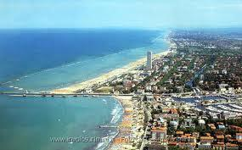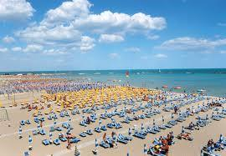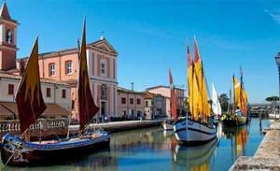

22/24 September Morocco – Casablanca
email : luyufoo@hotmail.com

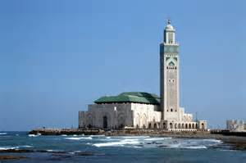

07-08 October England - Bracknell
email : peter@bracknellgymnasticsclub.co.uk

04 November France – Kingersheim
email : luyufoo@hotmail.com

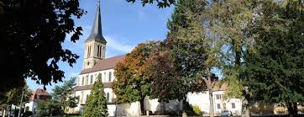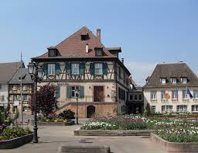

24 - 25 November Spain – Gran Canaria
email : jesus.telo@online.de

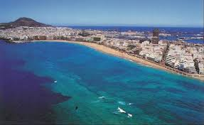

Sponsored by:

Web site : www.villaggioaccademia.it
Mail : direzione@villaggioaccademia.it

